**Week 6**

**Penetration Testing Report**

**Introduction**

This report document hereby describes the proceedings and results of a Black Box security assessment conducted against the **Week 6 Labs**. The report hereby lists the findings and corresponding best practice mitigation actions and recommendations.

**1. Objective**

The objective of the assessment was to uncover vulnerabilities in the **Week 6 Labs** and provide a final security assessment report comprising vulnerabilities, remediation strategy and recommendation guidelines to help mitigate the identified vulnerabilities and risks during the activity.

**2. Scope**

This section defines the scope and boundaries of the project.

| **Application Name** |  |
| --- | --- |

**3. Summary**

Outlined is a Black Box Application Security assessment for the **Week 6 Labs**.

**Total number of Sub-labs: 6 Sub-labs**

| **High** | **Medium** | **Low** |
| --- | --- | --- |
| **2** | **2** | **2** |

**High - Number of Sub-labs with hard difficulty level**

**Medium - Number of Sub-labs with Medium difficulty level**

**Low - Number of Sub-labs with Easy difficulty level**

# 1. Cross-Site Request Forgery

# 1.1. Eassyy CSRF

| **Reference** | **Risk Rating** |  |
| --- | --- | --- |
| Eassyy CSRF | **High** |  |
| **Tools Used** | |  |
| Burp Suite | |  |
| **Vulnerability Description** | |  |
| Cross-Site Request Forgery (CSRF) is an attack that forces an end user to execute unwanted actions on a web application in which they’re currently authenticated. With a little help of social engineering an attacker may trick the users of a web application into executing actions of the attacker’s choosing. If the victim is a normal user, a successful CSRF attack can force the user to perform state changing requests like transferring funds, changing their email address, and so forth. If the victim is an administrative account, CSRF can compromise the entire web application. | |  |
| **How It Was Discovered** | |  |
| Manual Analysis | |  |
| **Vulnerable URLs** | |  |
| <https://www.bugbountyhunter.org/internship_labs/HTML/csrf_lab/lab_1/login.php> | |  |
| **Consequences of not Fixing the Issue** | |  |
| In a successful CSRF attack, the attacker causes the victim user to carry out an action  unintentionally. Depending on the nature of the action, the attacker might be able to gain full  control over the user's account. If the compromised user has a privileged role within the  application, then the attacker might be able to take full control of all the application's data and  functionality. | |  |
| **Suggested Countermeasures** | |  |
| **Same Site Cookies:** CSRF attacks are only possible since Cookies are always sent with any  requests that are sent to a particular origin, which is related to that Cookie. Due to the nature  of a CSRF attack, a flag can be set against a Cookie, tuning it into a same-site Cookie. A  Cross Site Request Forgery (CSRF) 7  same-site Cookie is a Cookie which can only be sent, if the request is being made from the  same origin that is related to the Cookie being sent. | |  |
| **References** | |  |
| <https://en.wikipedia.org/wiki/Cross-site_request_forgery>  <https://www.acunetix.com/websitesecurity/csrf-attacks/>  <https://owasp.org/www-community/attacks/csrf> | |  |

# 

# Proof of Concept

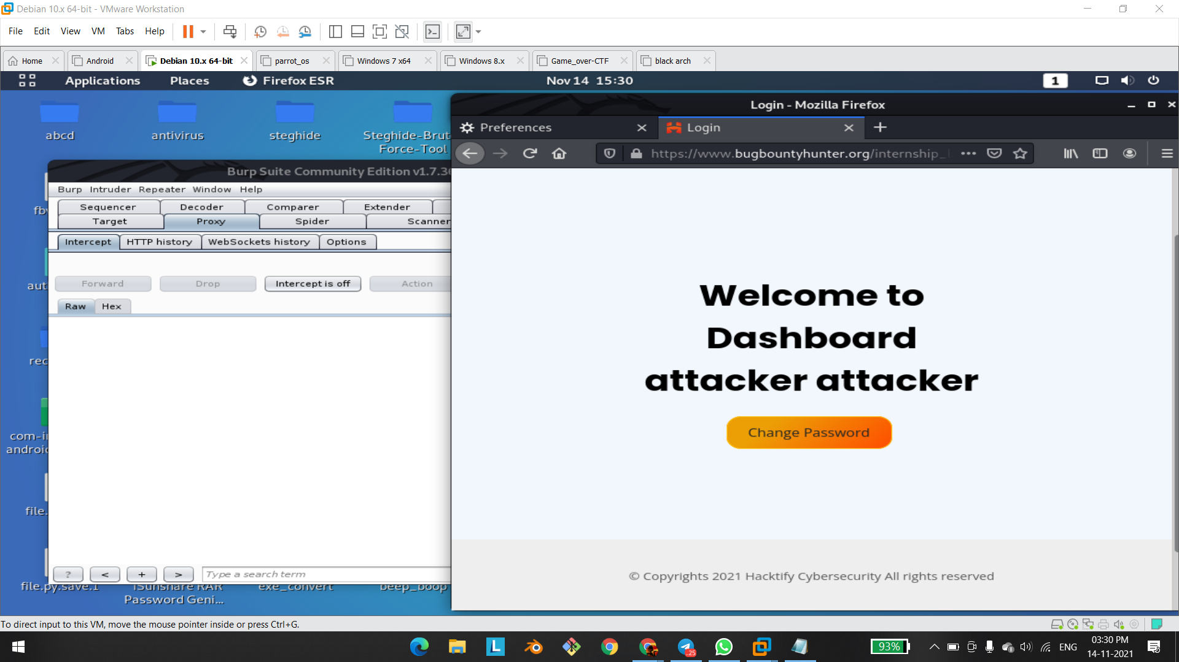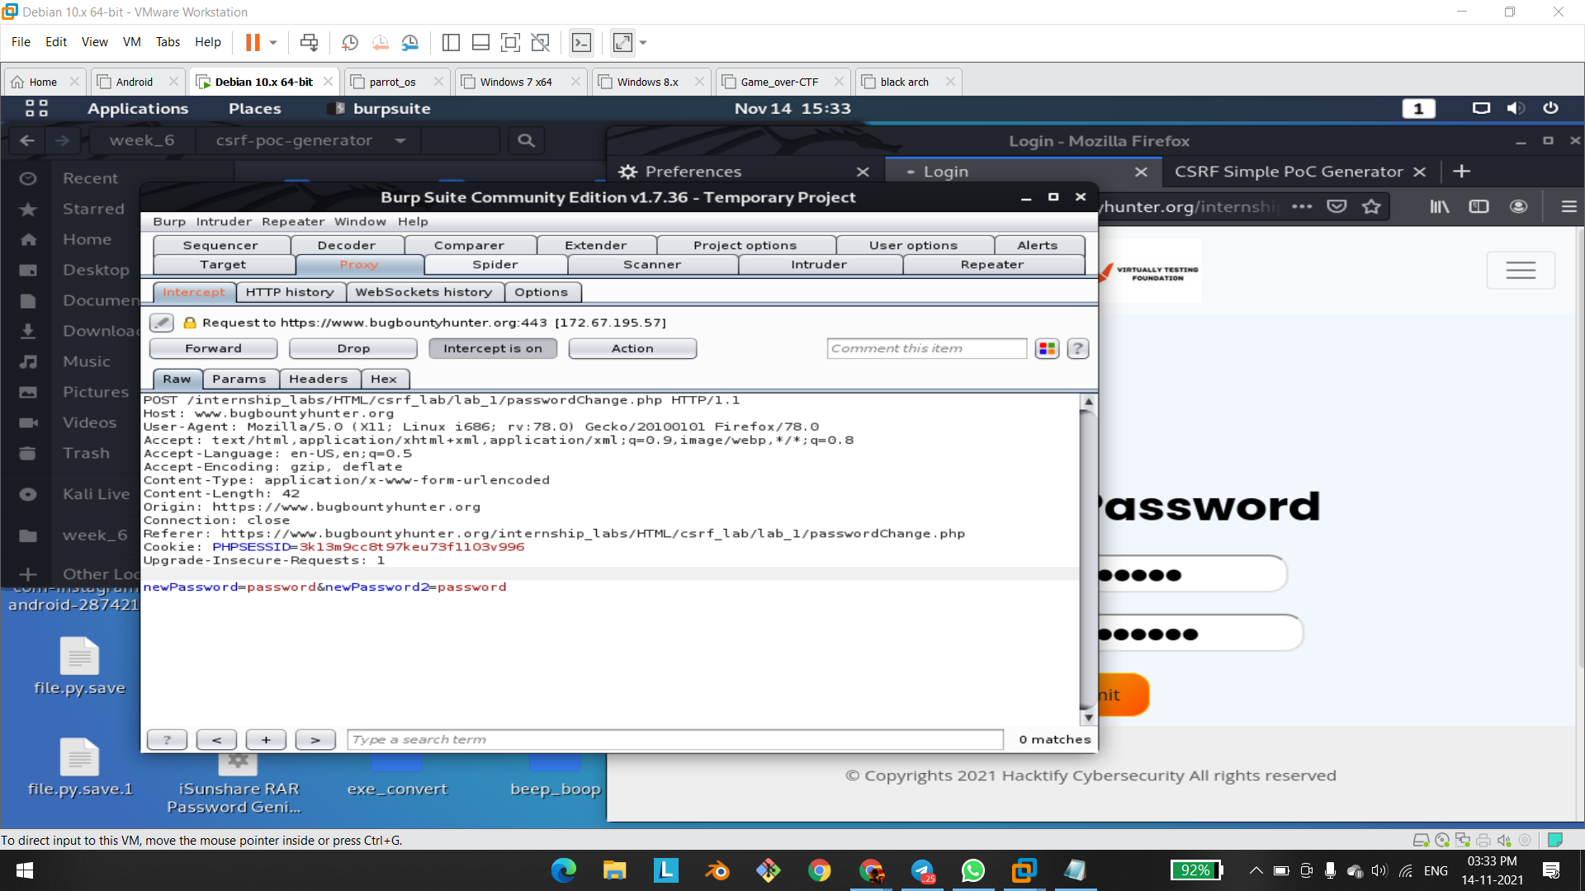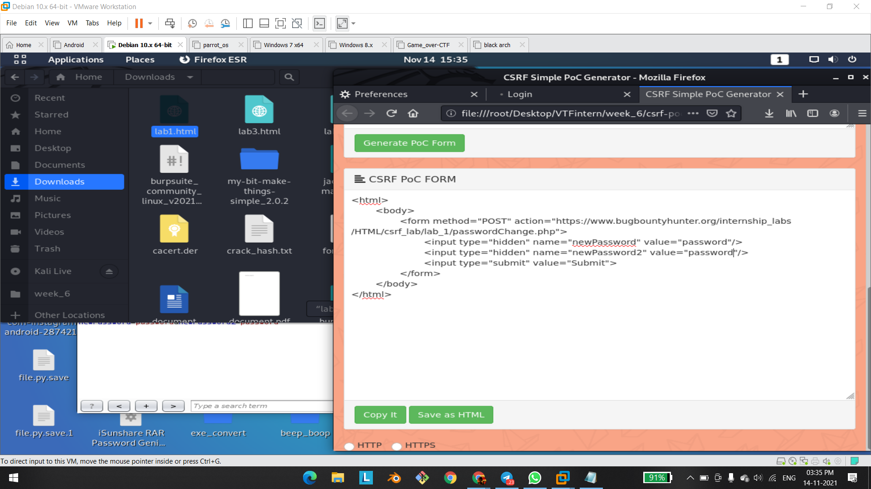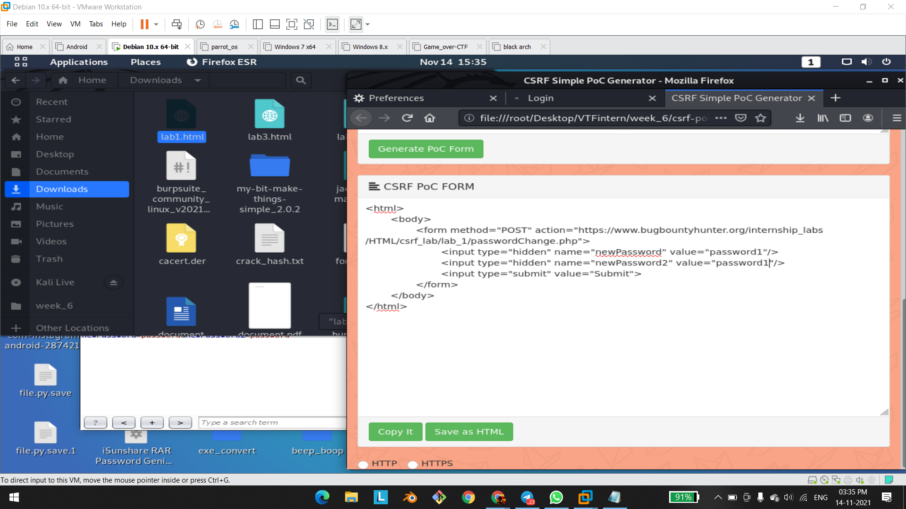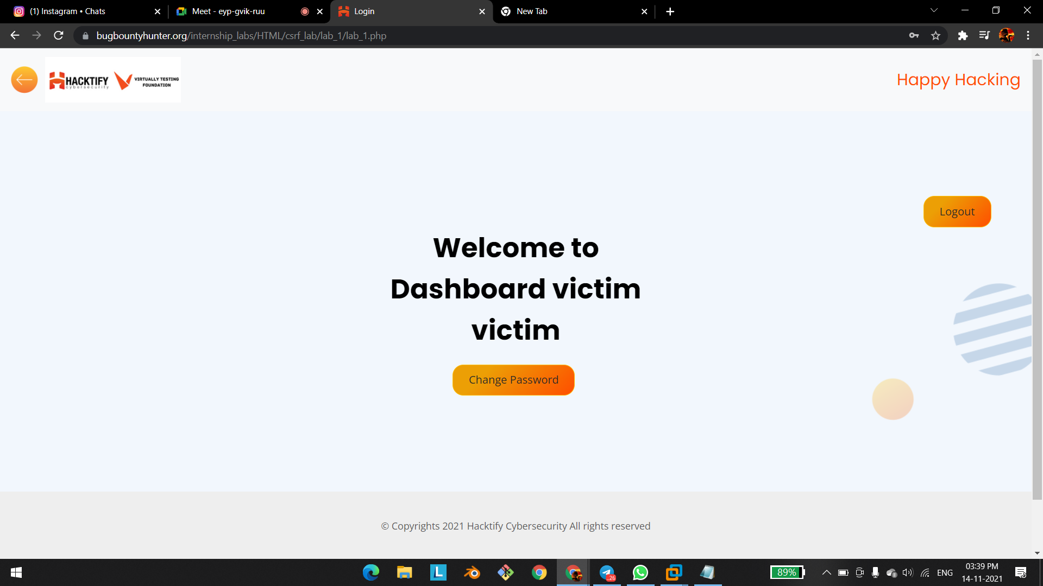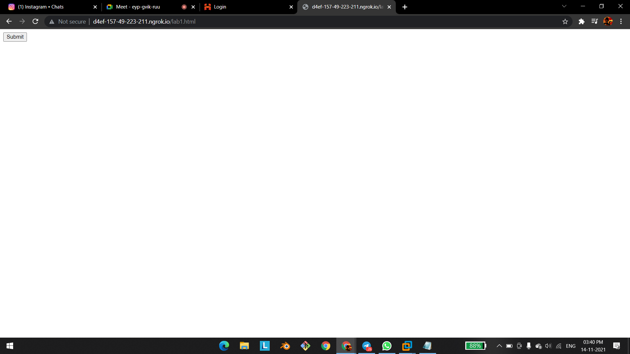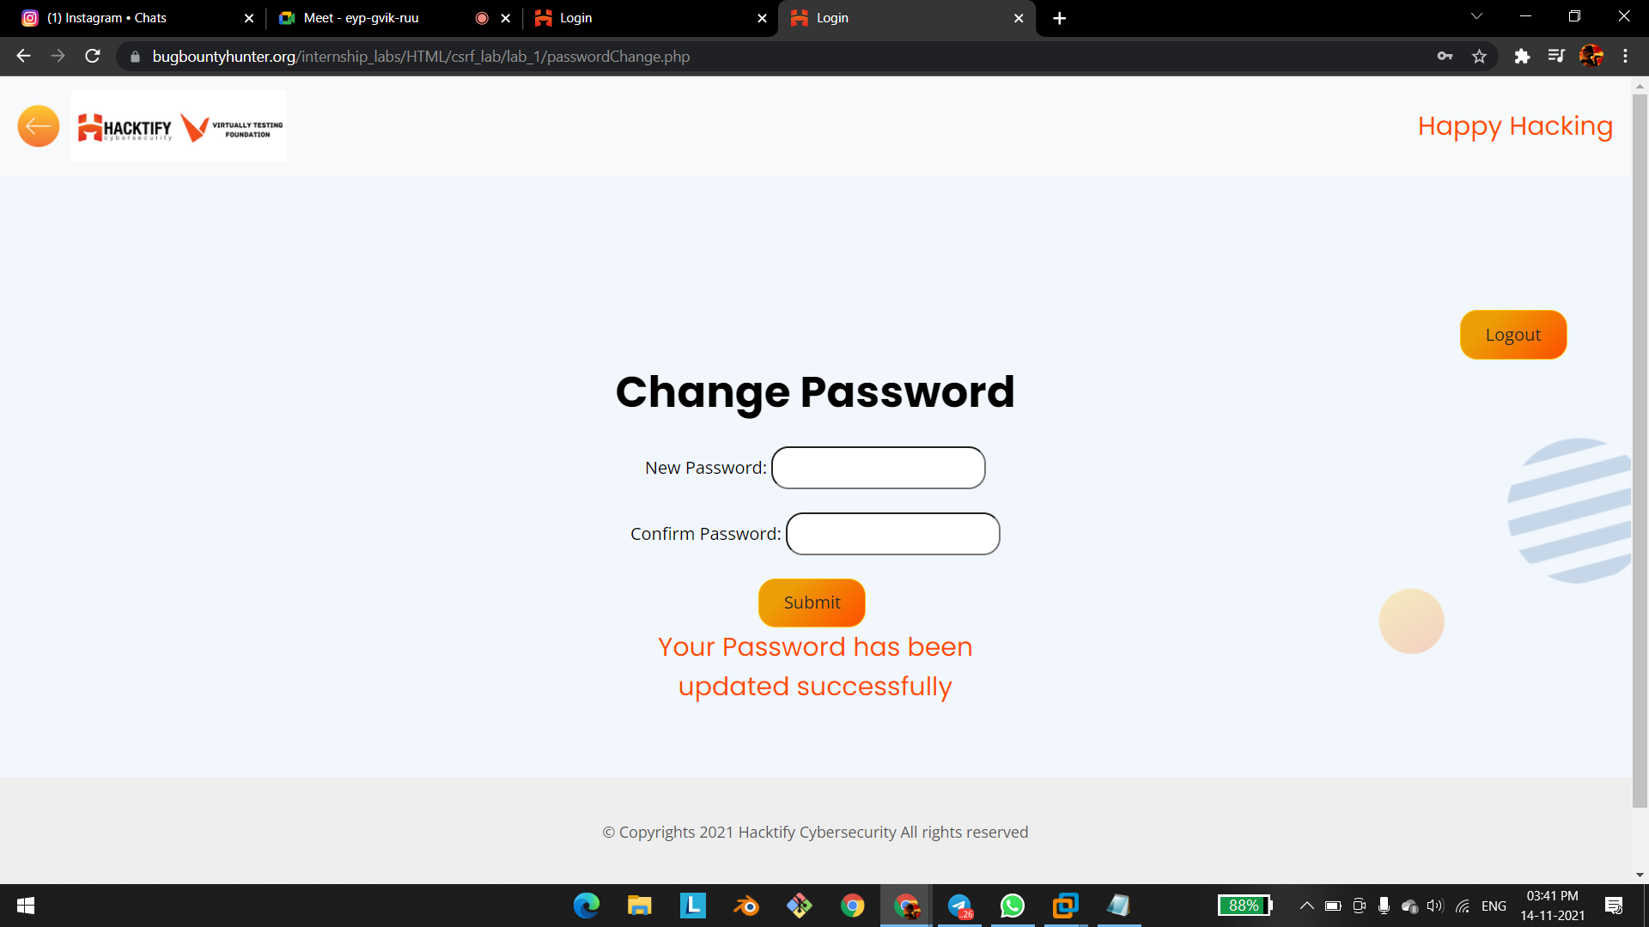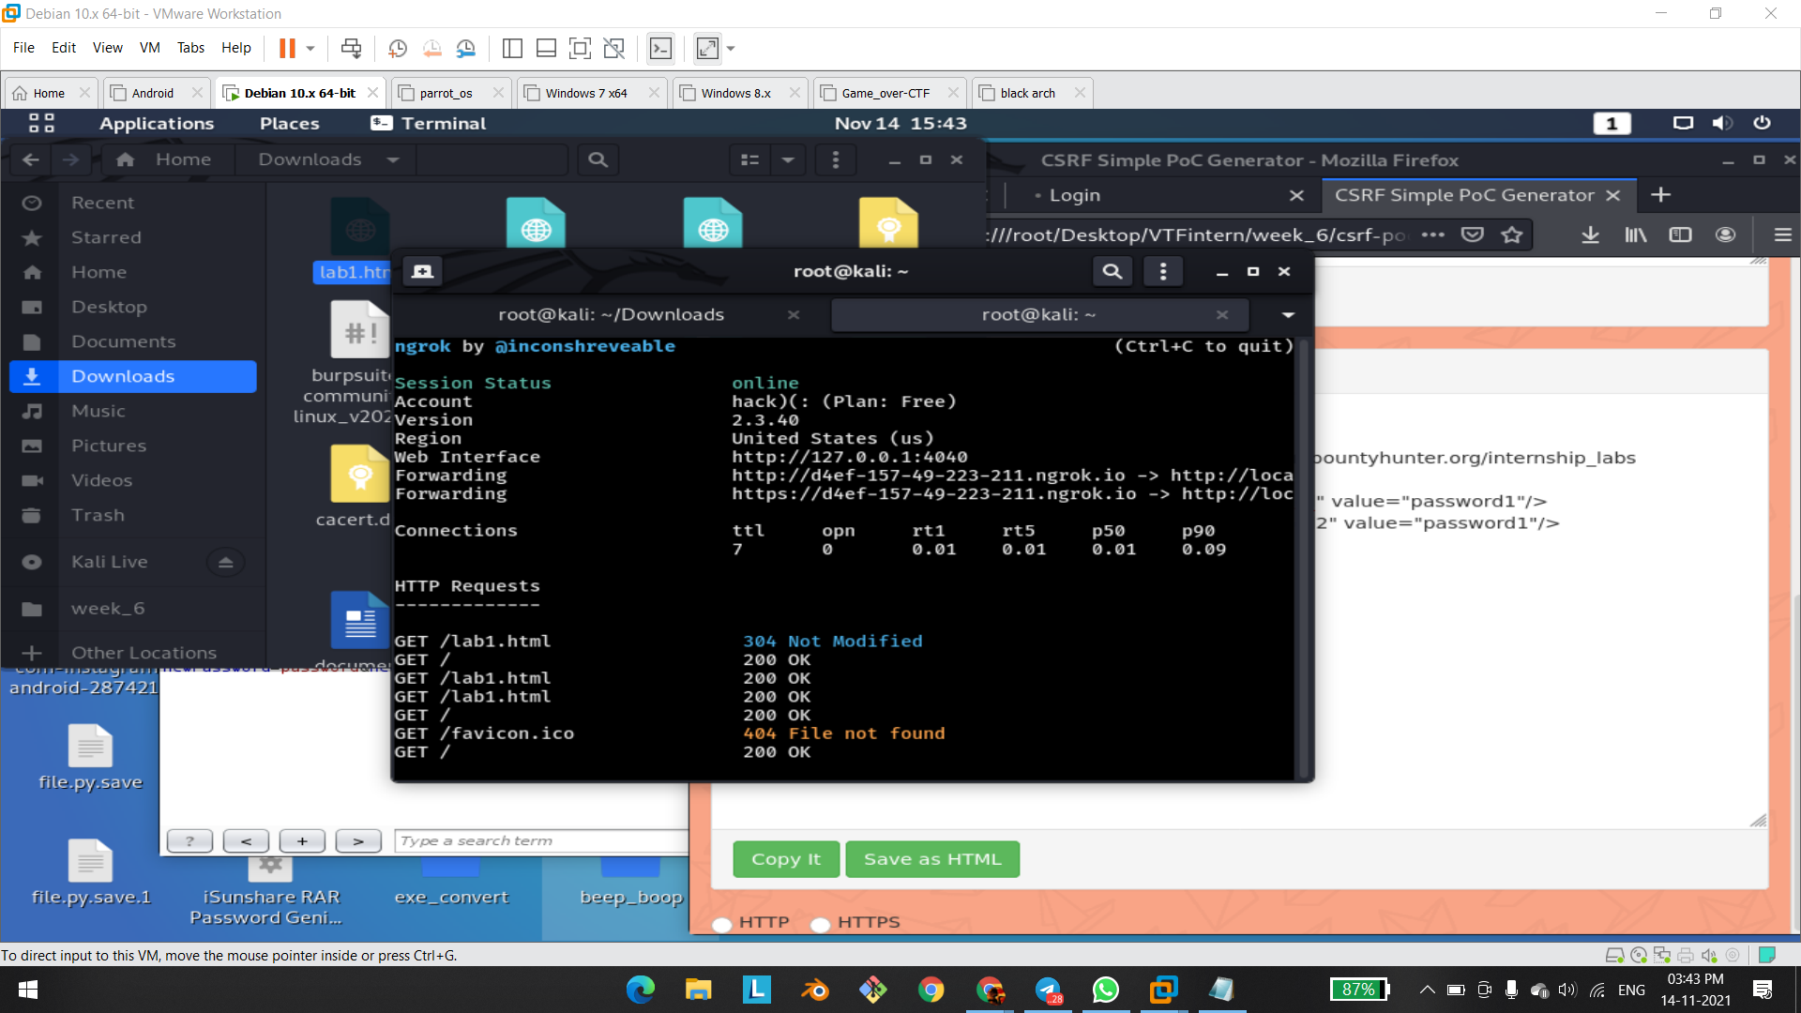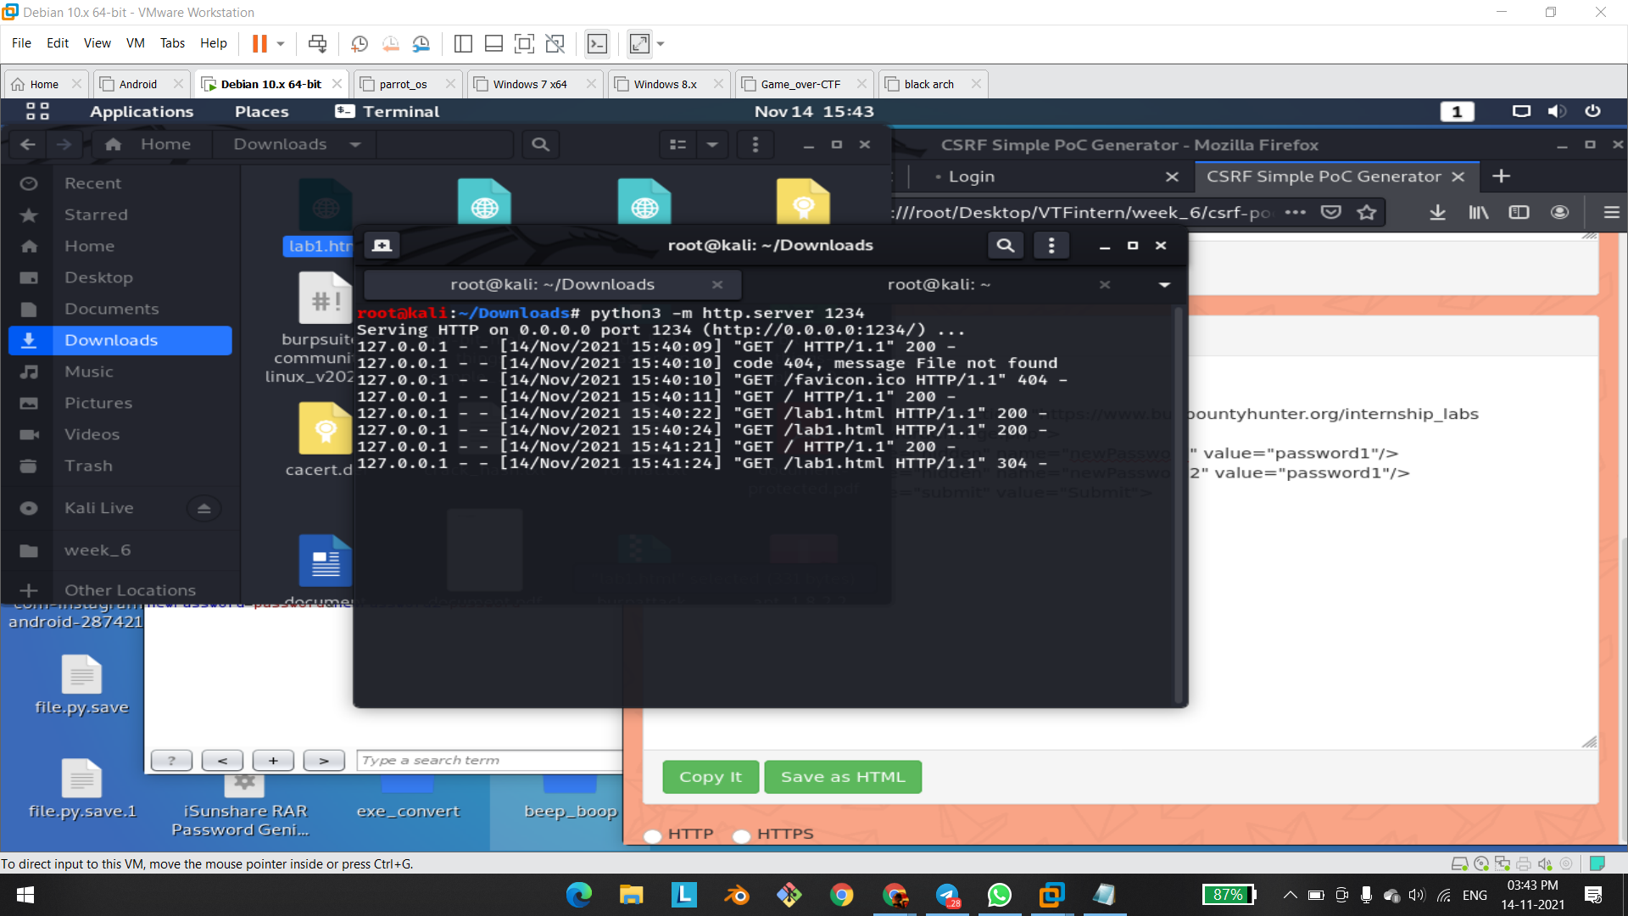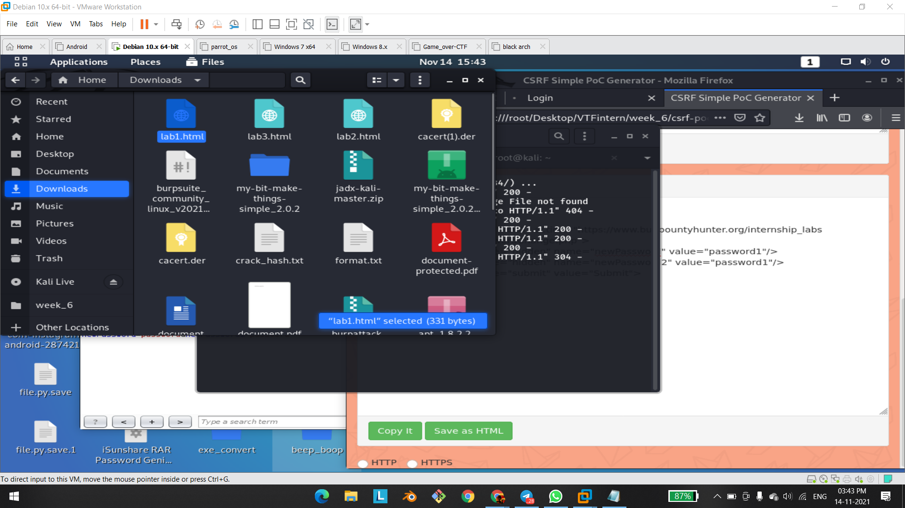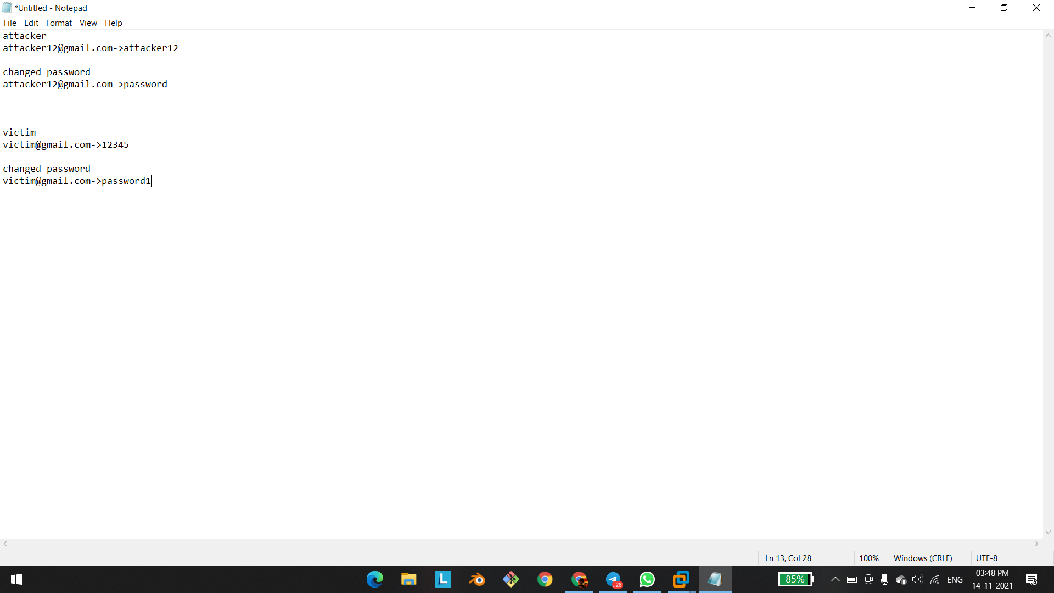

# 

# 

# 

# 

# 

# 1.2.Always Validate Tokens

| **Reference** | **Risk Rating** |
| --- | --- |
| Always Validate Tokens | **High** |
| **Tools Used** | |
| Burp Suite | |
| **Vulnerability Description** | |
| Cross-Site Request Forgery (CSRF) is an attack that forces an end user to execute unwanted actions on a web application in which they’re currently authenticated. With a little help of social engineering an attacker may trick the users of a web application into executing actions of the attacker’s choosing. If the victim is a normal user, a successful CSRF attack can force the user to perform state changing requests like transferring funds, changing their email address, and so forth. If the victim is an administrative account, CSRF can compromise the entire web application. | |
| **How It Was Discovered** | |
| Manual Analysis | |
| **Vulnerable URLs** | |
| <https://www.bugbountyhunter.org/internship_labs/HTML/csrf_lab/lab_2/login.php> | |
| **Consequences of not Fixing the Issue** | |
| In a successful CSRF attack, the attacker causes the victim user to carry out an action  unintentionally. Depending on the nature of the action, the attacker might be able to gain full  control over the user's account. If the compromised user has a privileged role within the  application, then the attacker might be able to take full control of all the application's data and  functionality. | |
| **Suggested Countermeasures** | |
| **Anti-CSRF Tokens:** Use a token that is associated with a particular user and can be found as  a hidden value in every state changing form which is present on the web application. This  token, called a CSRF Token or a Synchronizer Token | |
| **References** | |
| <https://www.acunetix.com/websitesecurity/csrf-attacks/>  <https://owasp.org/www-community/attacks/csrf> | |

# Proof of Concept

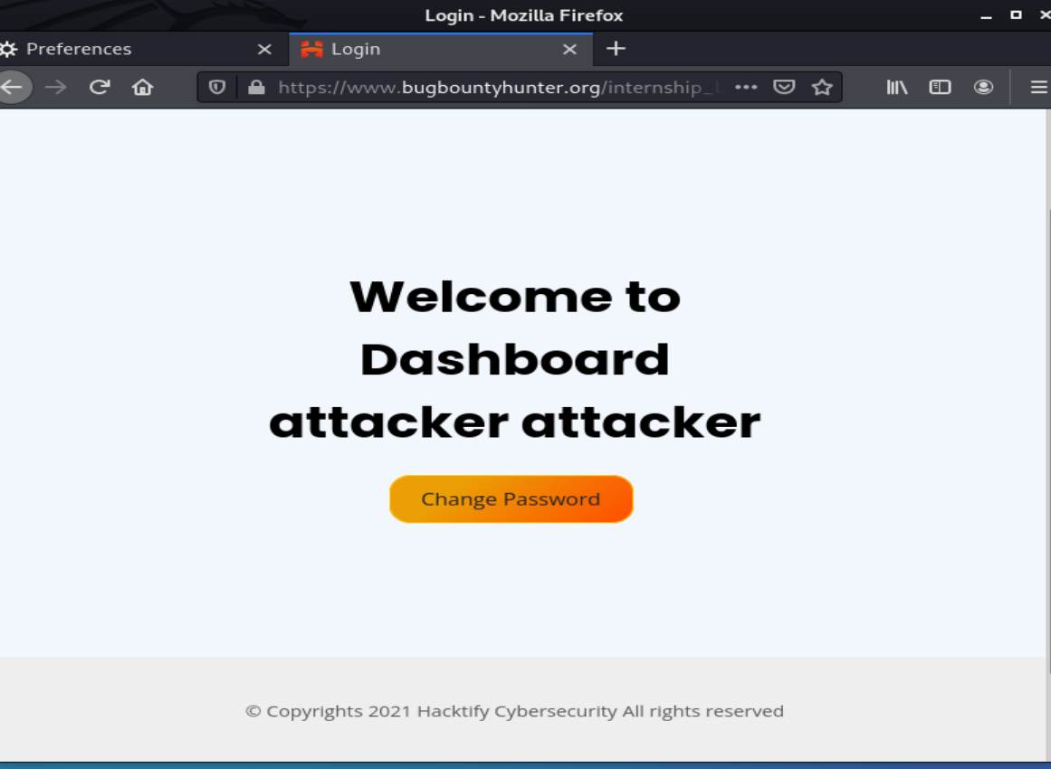

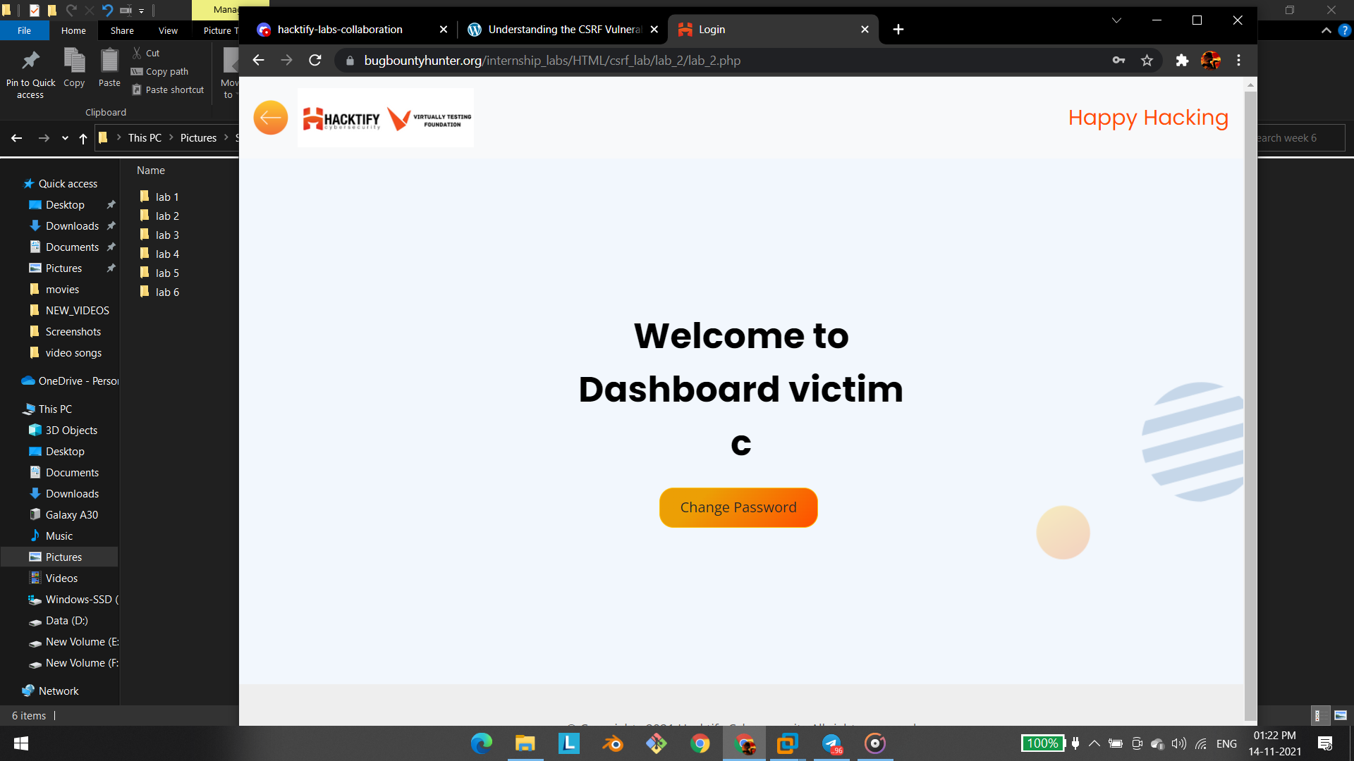

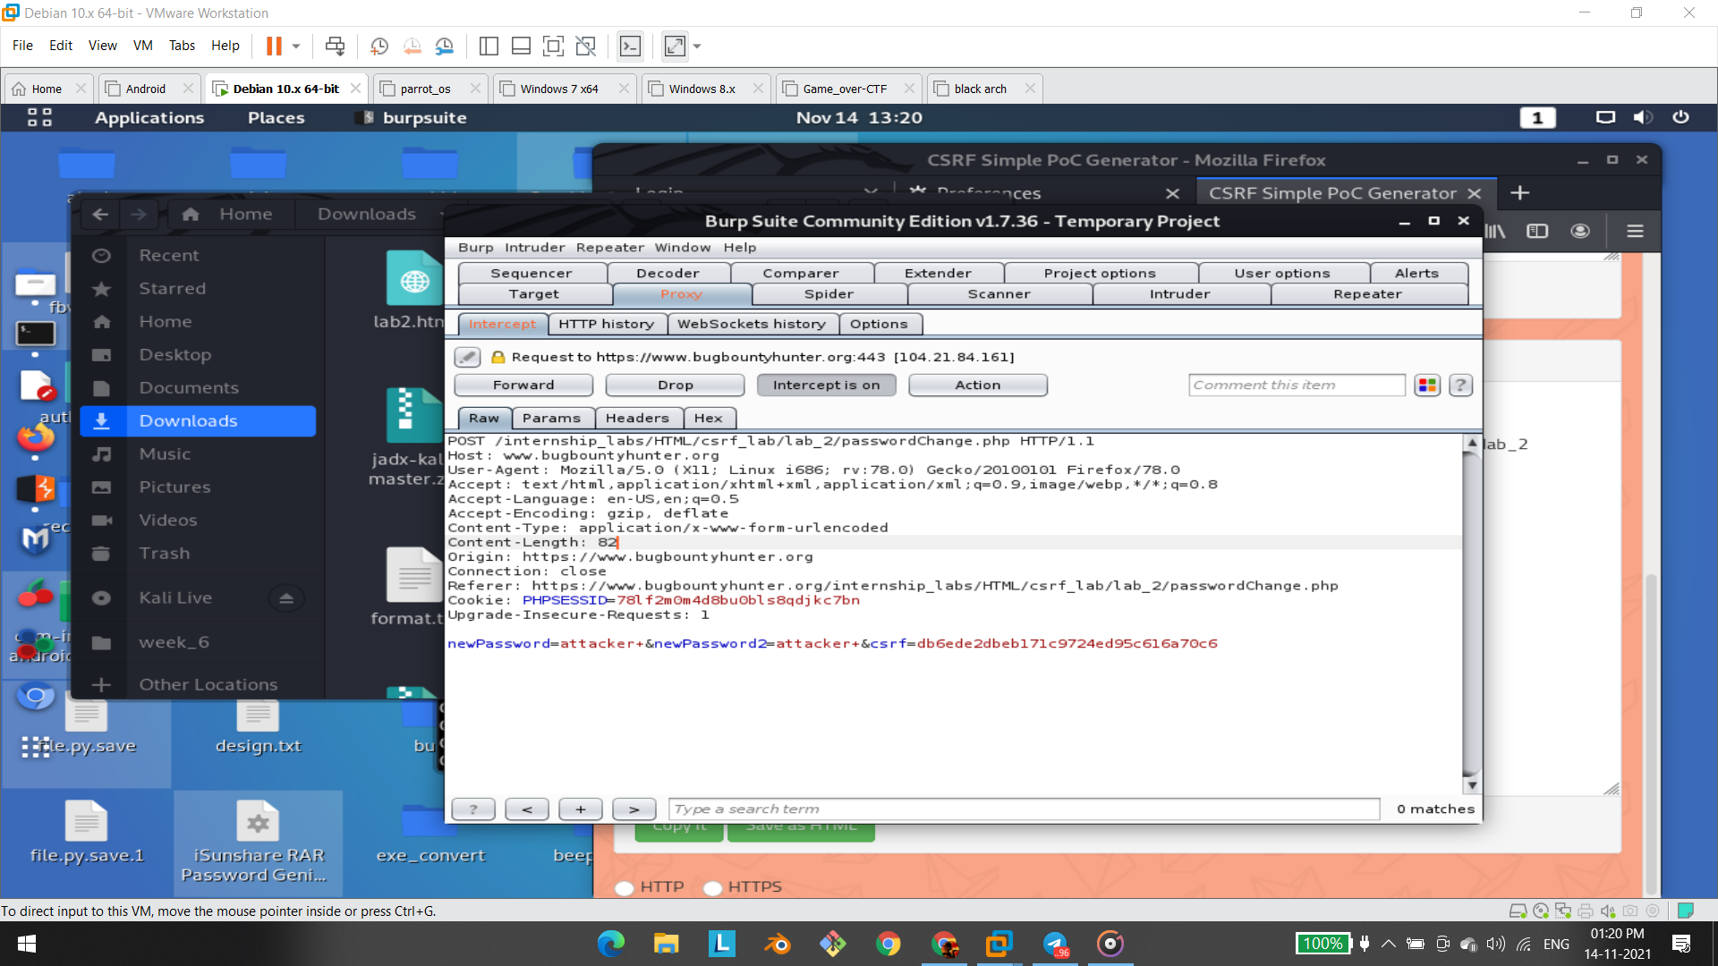

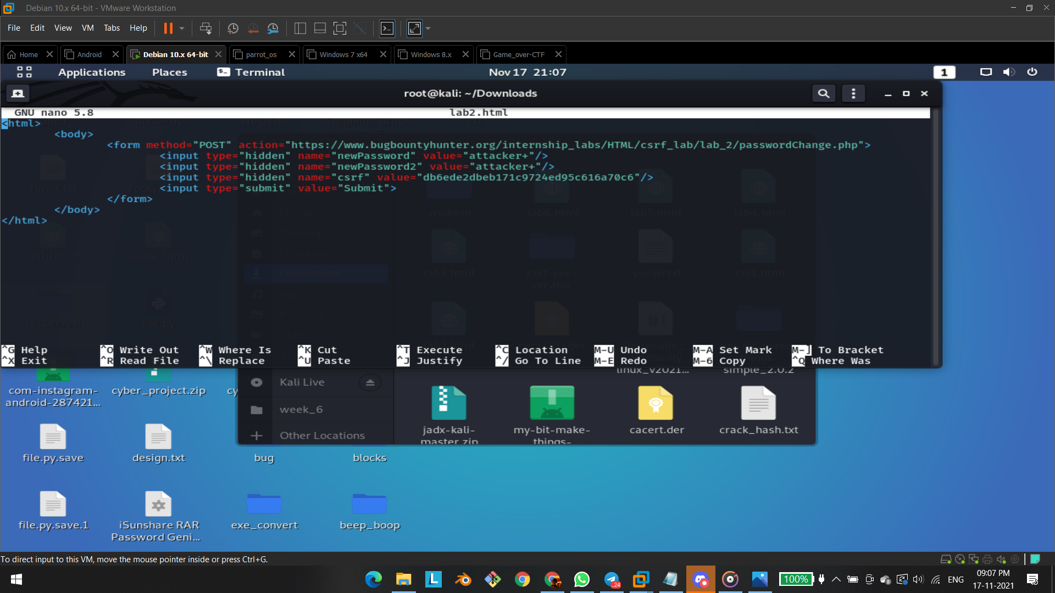

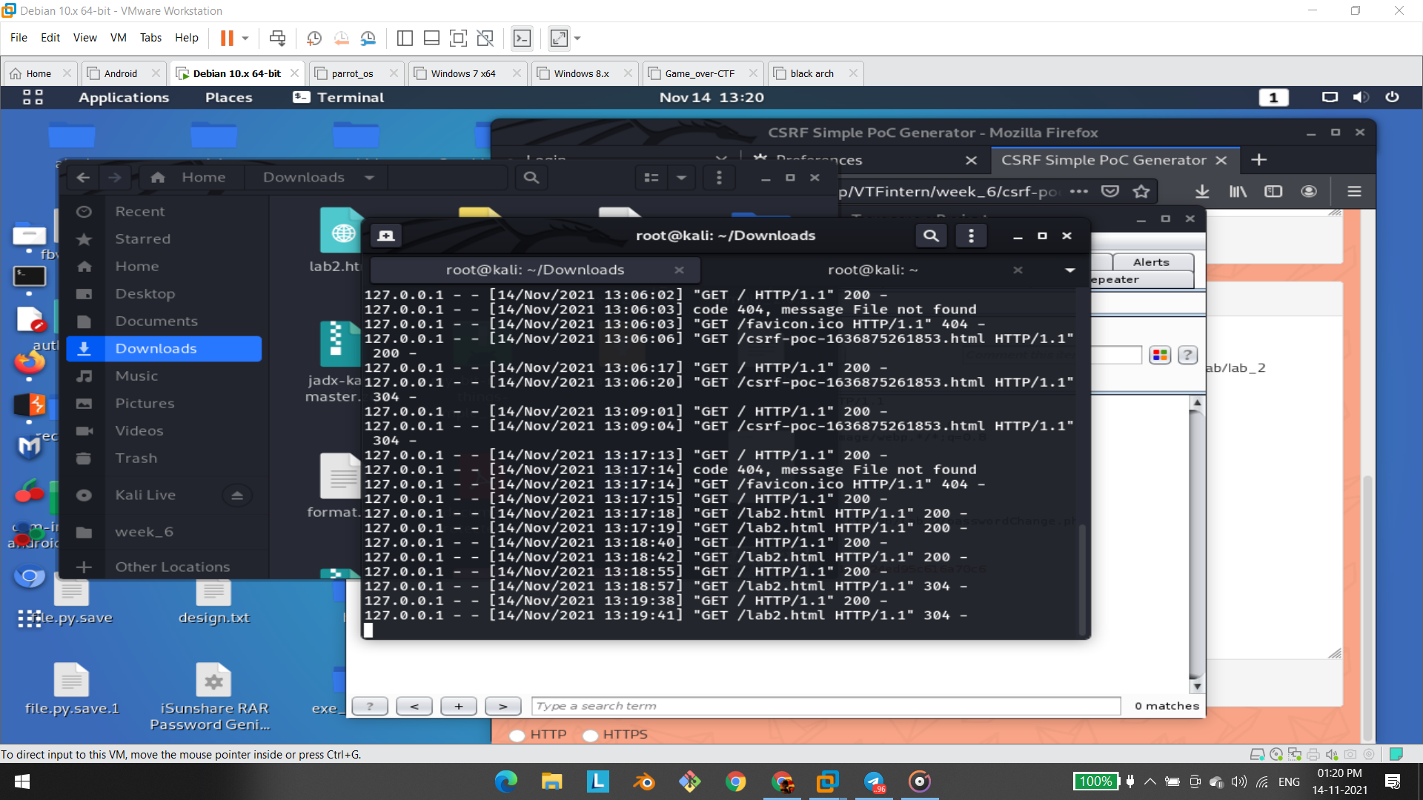

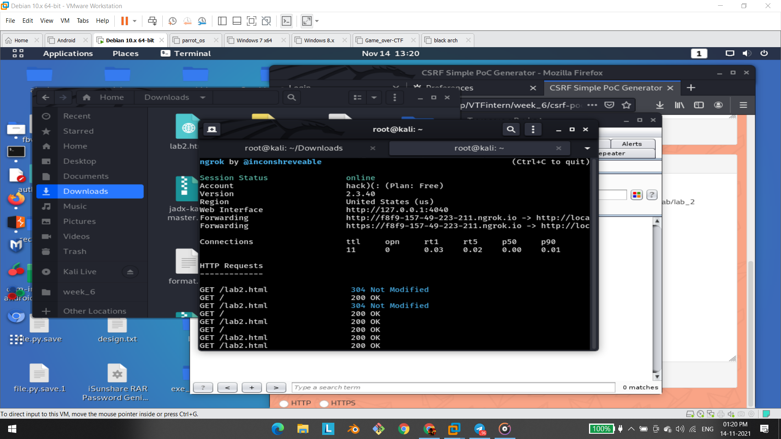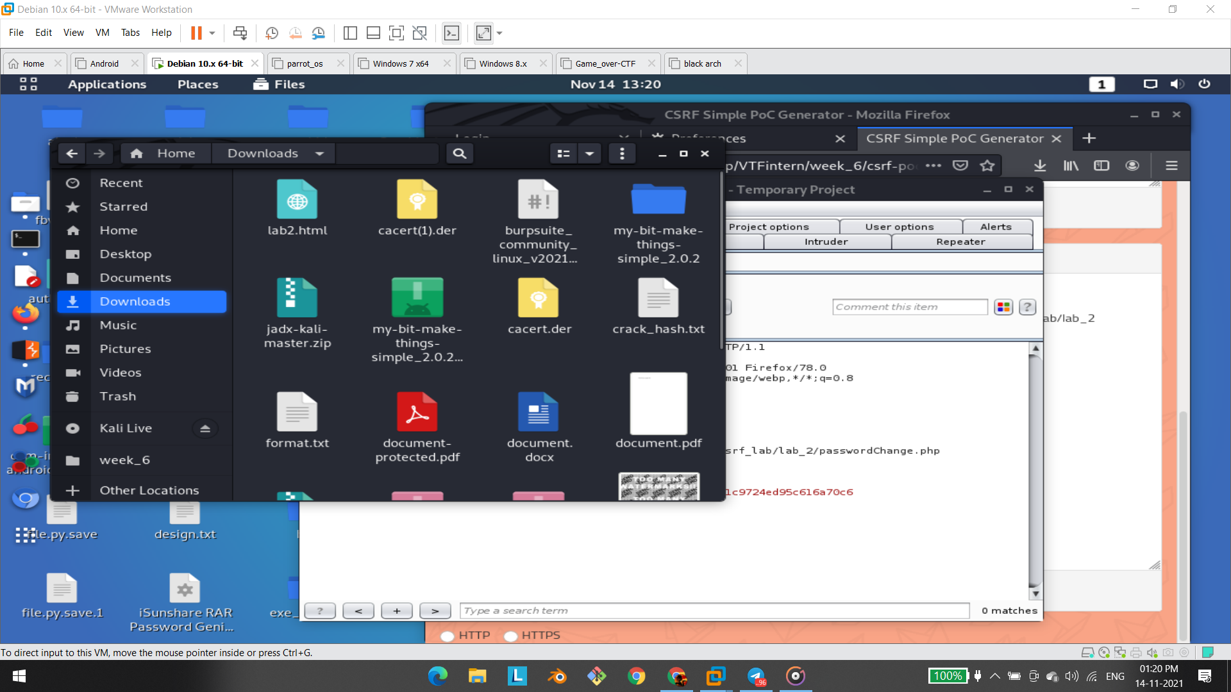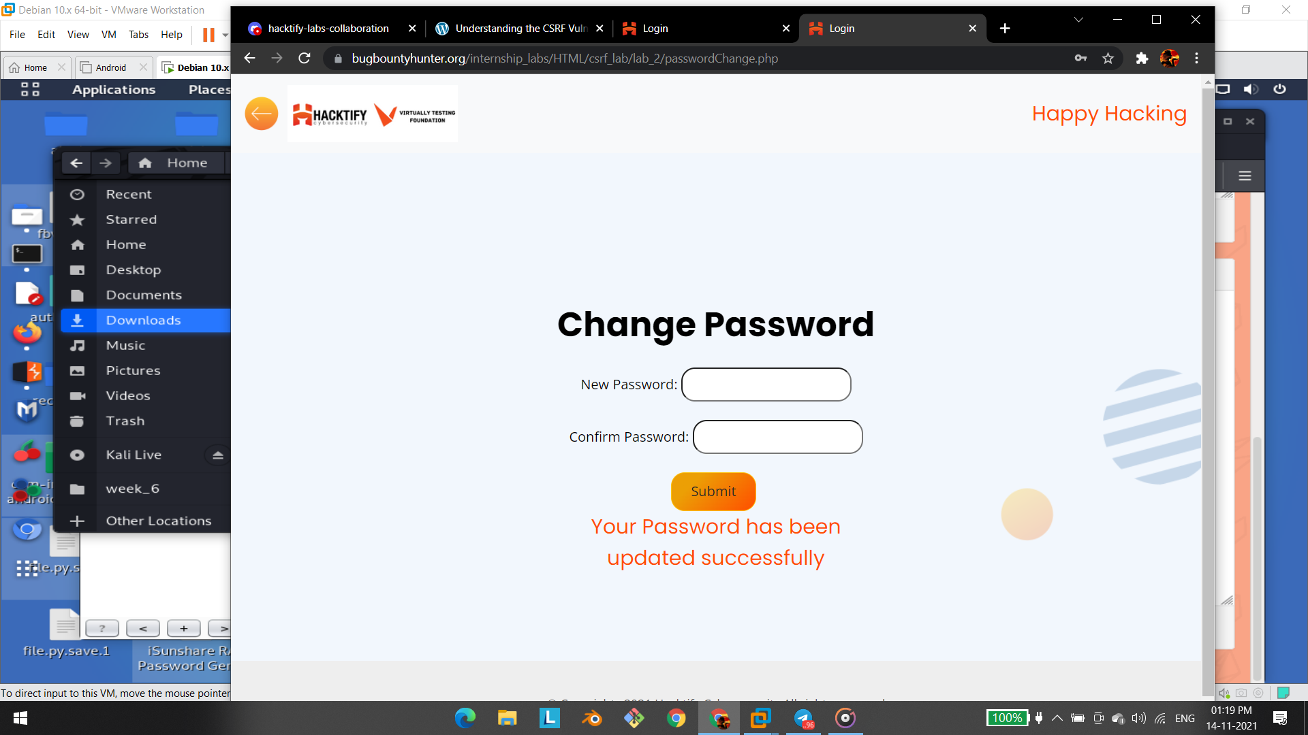

# 1.3.I Hate When Someone Uses My Tokens!

| **Reference** | **Risk Rating** |
| --- | --- |
| I Hate When Someone Uses My Tokens! | **High** |
| **Tools Used** | |
| Burp Suite | |
| **Vulnerability Description** | |
| Cross-Site Request Forgery (CSRF) is an attack that forces an end user to execute unwanted actions on a web application in which they’re currently authenticated. With a little help of social engineering an attacker may trick the users of a web application into executing actions of the attacker’s choosing. If the victim is a normal user, a successful CSRF attack can force the user to perform state changing requests like transferring funds, changing their email address, and so forth. If the victim is an administrative account, CSRF can compromise the entire web application. | |
| **How It Was Discovered** | |
| Manual Analysis | |
| **Vulnerable URLs** | |
| <https://www.bugbountyhunter.org/internship_labs/HTML/csrf_lab/lab_4/login.php> | |
| **Consequences of not Fixing the Issue** | |
| In a successful CSRF attack, the attacker causes the victim user to carry out an action  unintentionally. Depending on the nature of the action, the attacker might be able to gain full  control over the user's account. If the compromised user has a privileged role within the  application, then the attacker might be able to take full control of all the application's data and  functionality. | |
| **Suggested Countermeasures** | |
| **Anti-CSRF Tokens:** Use a token that is associated with a particular user and can be found as  a hidden value in every state changing form which is present on the web application. This  token, called a CSRF Token or a Synchronizer Token | |
| **References** | |
| <https://www.acunetix.com/websitesecurity/csrf-attacks/>  <https://owasp.org/www-community/attacks/csrf> | |

# 

# Proof of Concept

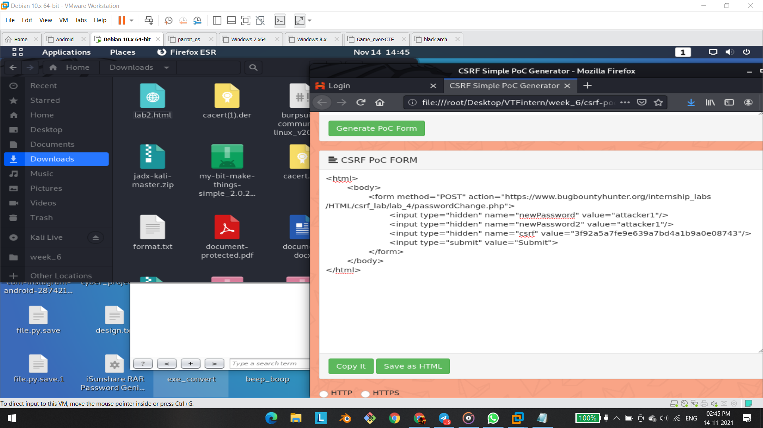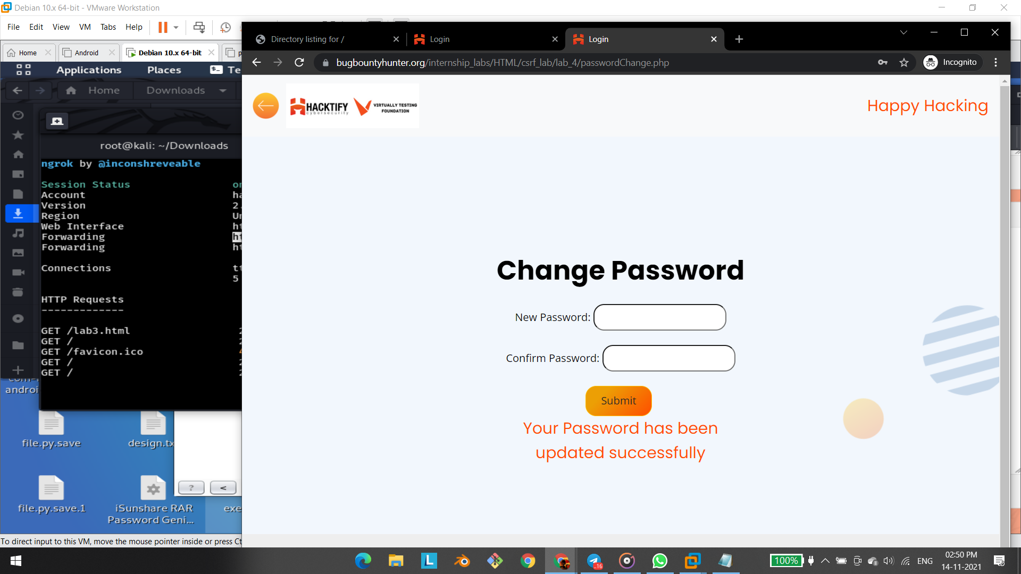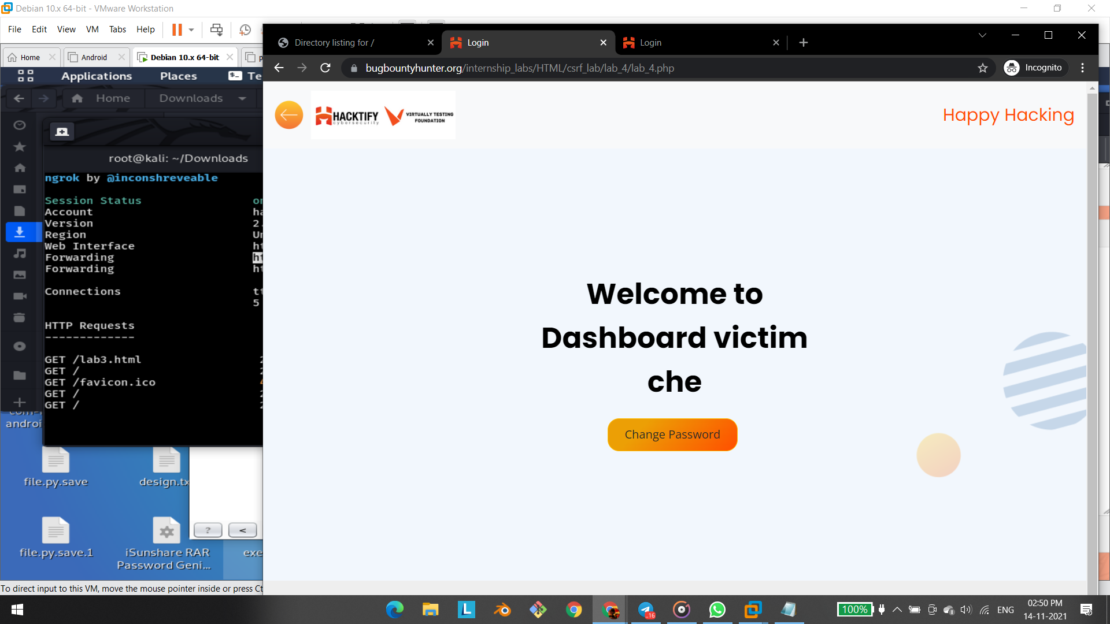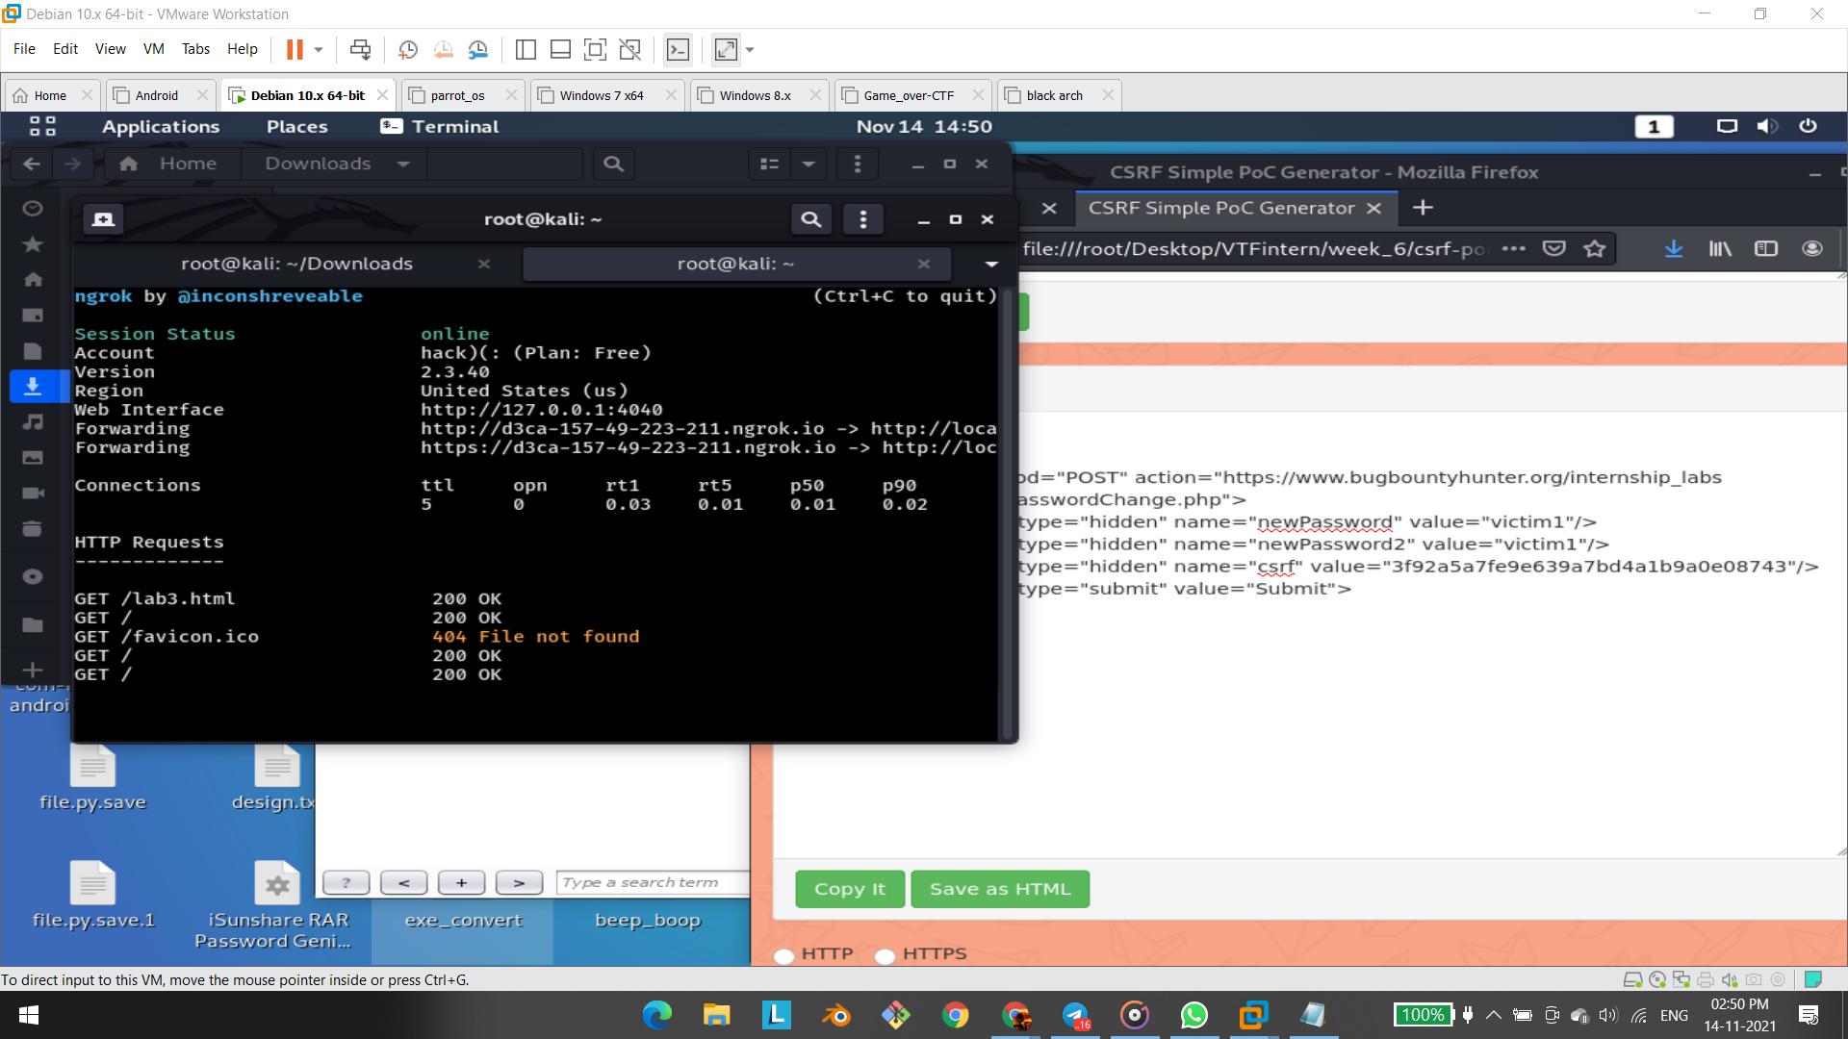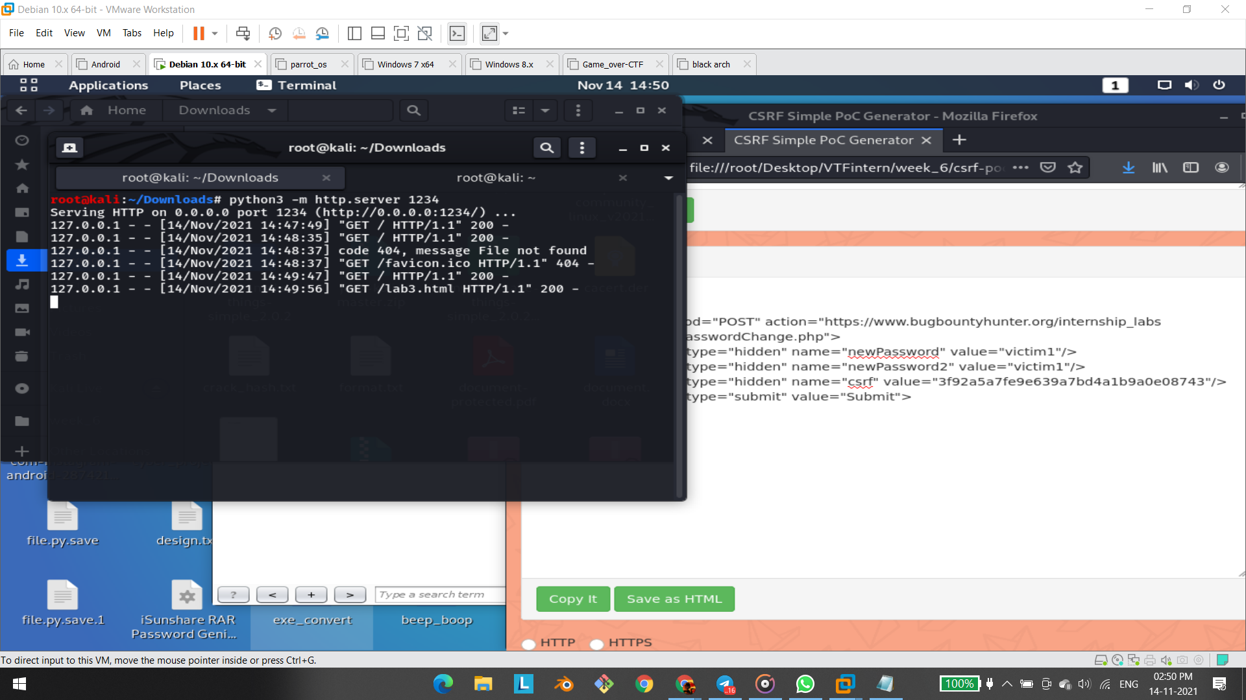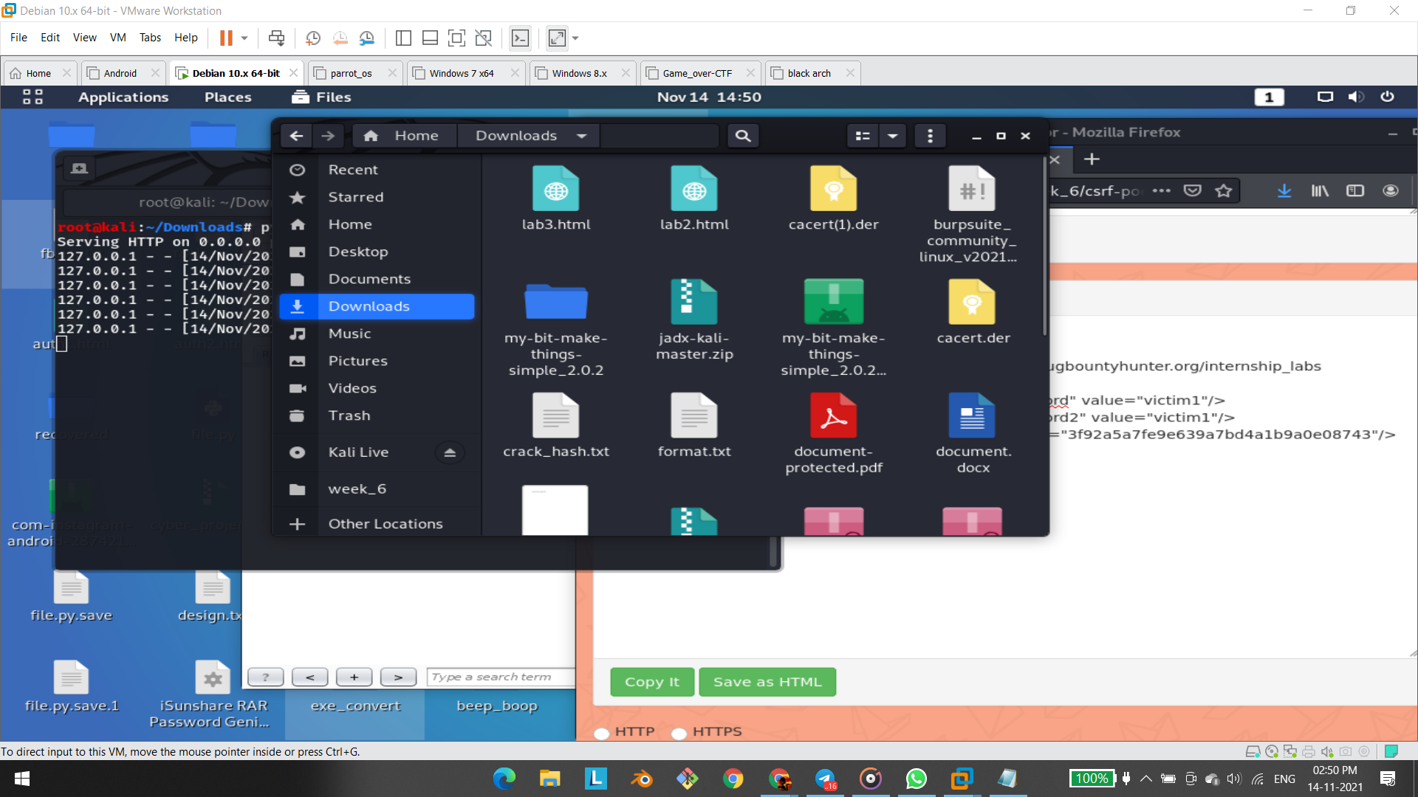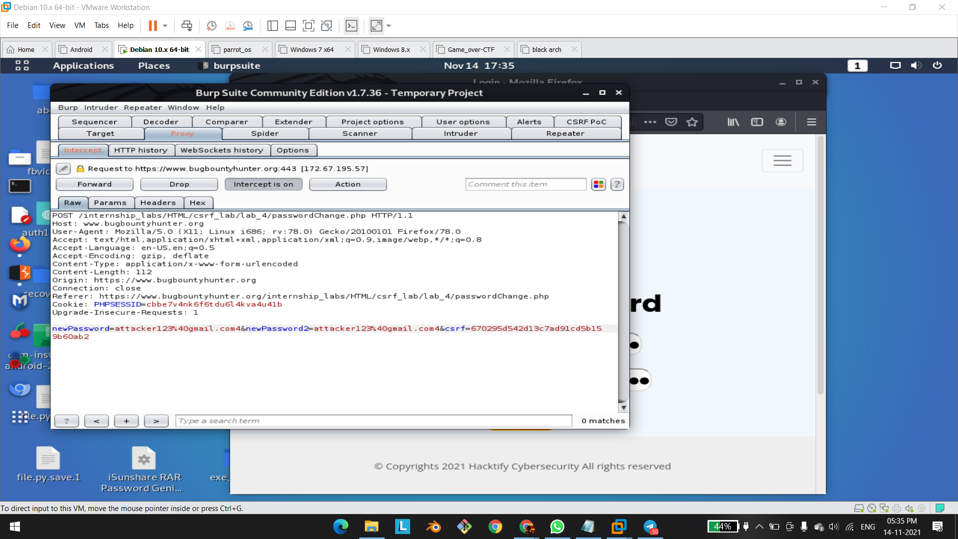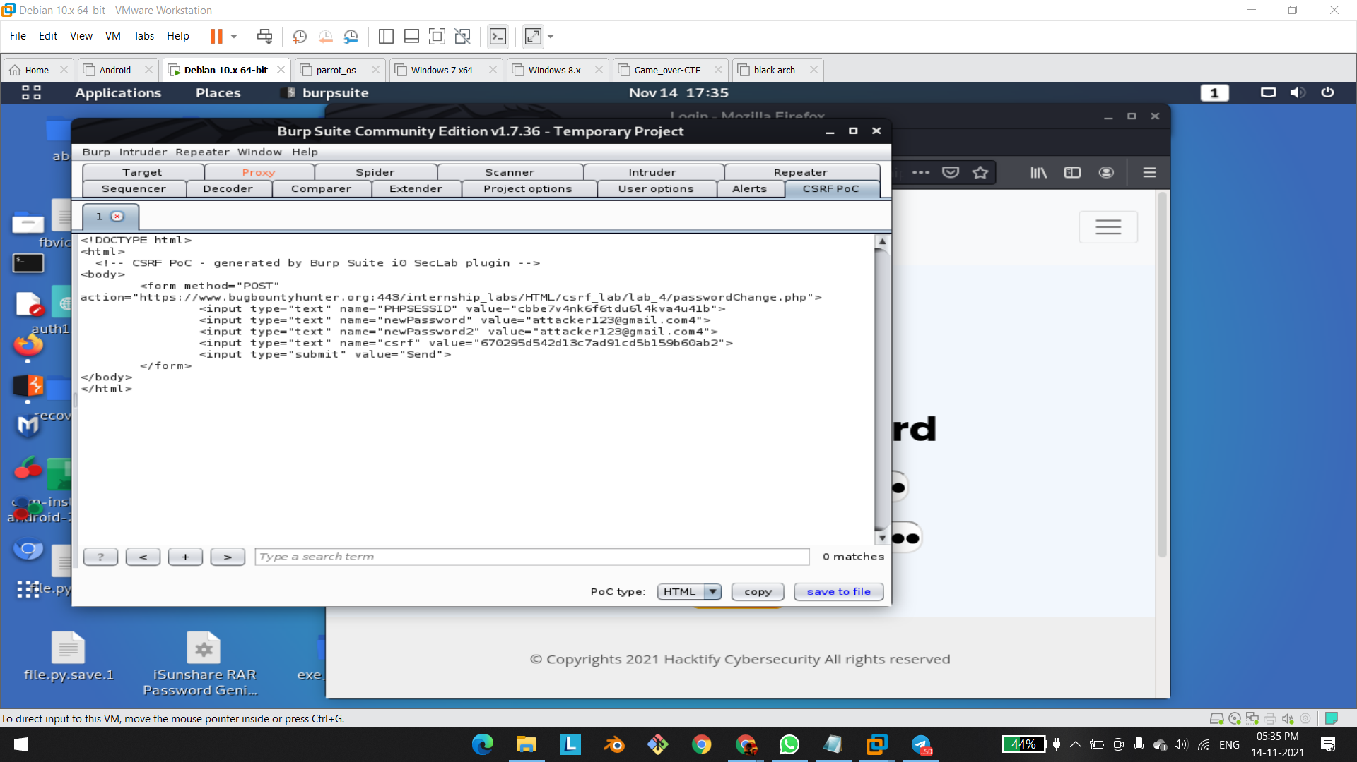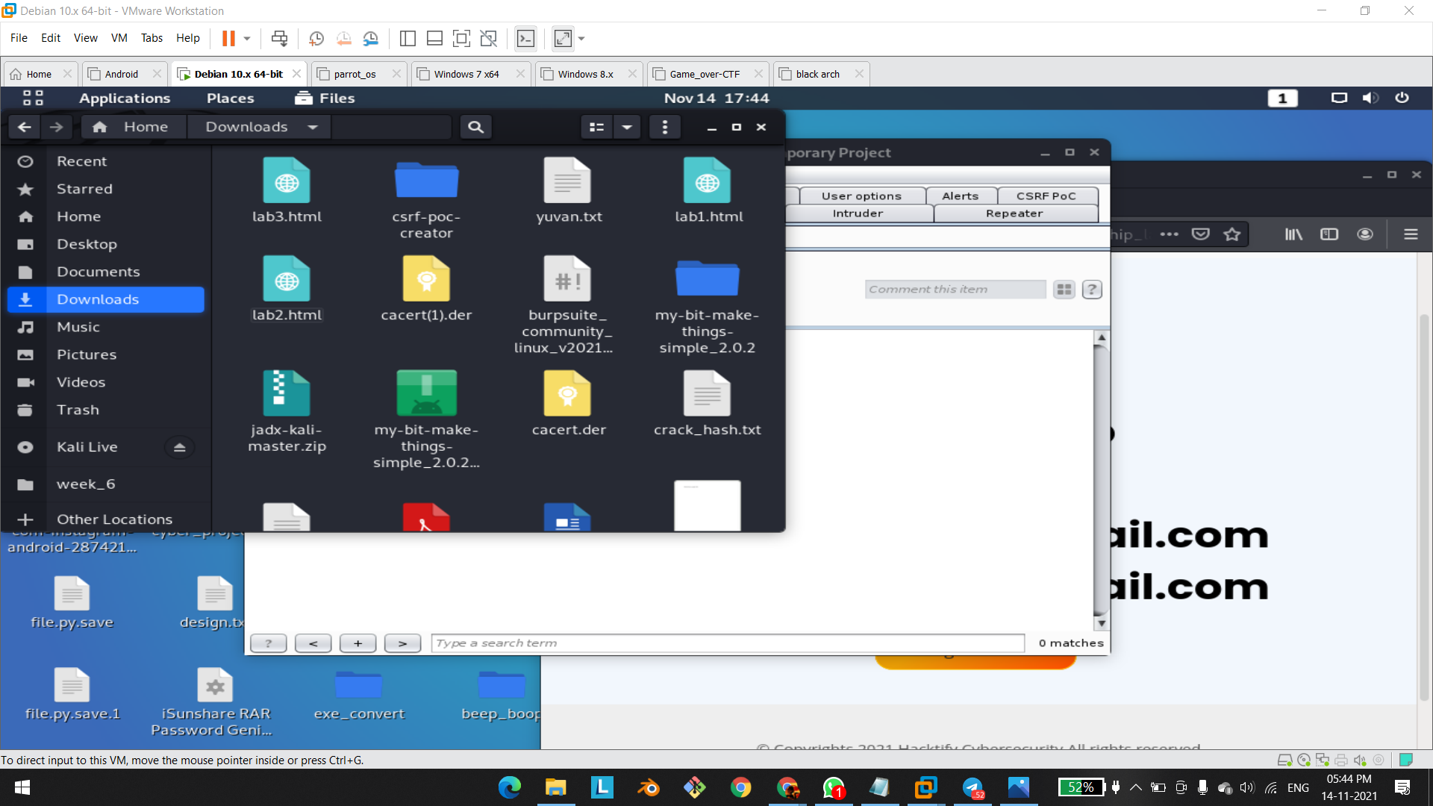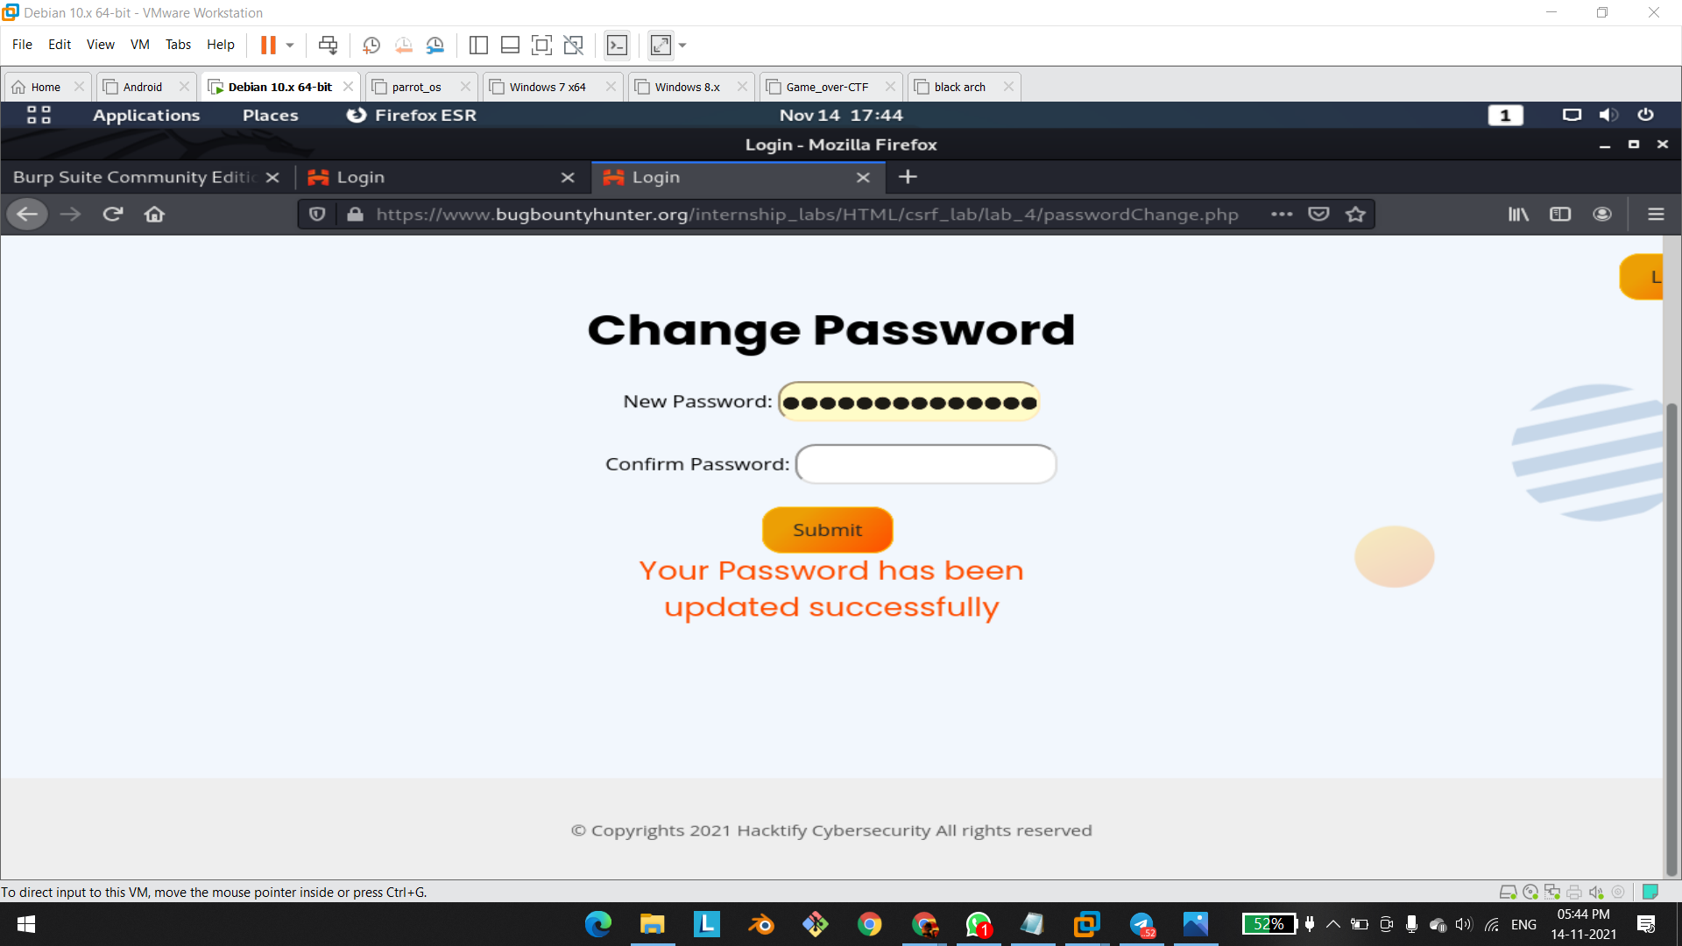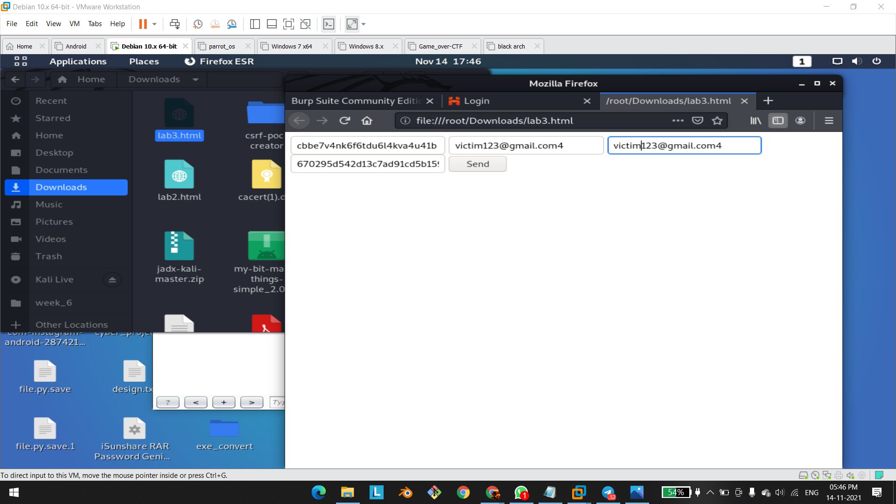

# 

# 

# 1.4. GET Me Or POST ME

| **Reference** | **Risk Rating** |
| --- | --- |
| GET Me Or POST ME | **High** |
| **Tools Used** | |
| Burp Suite | |
| **Vulnerability Description** | |
| Cross-Site Request Forgery (CSRF) is an attack that forces an end user to execute unwanted actions on a web application in which they’re currently authenticated. With a little help of social engineering an attacker may trick the users of a web application into executing actions of the attacker’s choosing. If the victim is a normal user, a successful CSRF attack can force the user to perform state changing requests like transferring funds, changing their email address, and so forth. If the victim is an administrative account, CSRF can compromise the entire web application. | |
| **How It Was Discovered** | |
| Manual Analysis | |
| **Vulnerable URLs** | |
| <https://www.bugbountyhunter.org/internship_labs/HTML/csrf_lab/lab_6/login.php> | |
| **Consequences of not Fixing the Issue** | |
| In a successful CSRF attack, the attacker causes the victim user to carry out an action  unintentionally. Depending on the nature of the action, the attacker might be able to gain full  control over the user's account. If the compromised user has a privileged role within the  application, then the attacker might be able to take full control of all the application's data and  functionality. | |
| **Suggested Countermeasures** | |
| Same Site Cookies: CSRF attacks are only possible since Cookies are always sent with any  requests that are sent to a particular origin, which is related to that Cookie. Due to the nature  of a CSRF attack, a flag can be set against a Cookie, tuning it into a same-site Cookie. A  Cross Site Request Forgery (CSRF) 7  same-site Cookie is a Cookie which can only be sent, if the request is being made from the  same origin that is related to the Cookie being sent. | |
| **References** | |
| <https://www.acunetix.com/websitesecurity/csrf-attacks/>  <https://owasp.org/www-community/attacks/csrf> | |

# 

# Proof of Concept

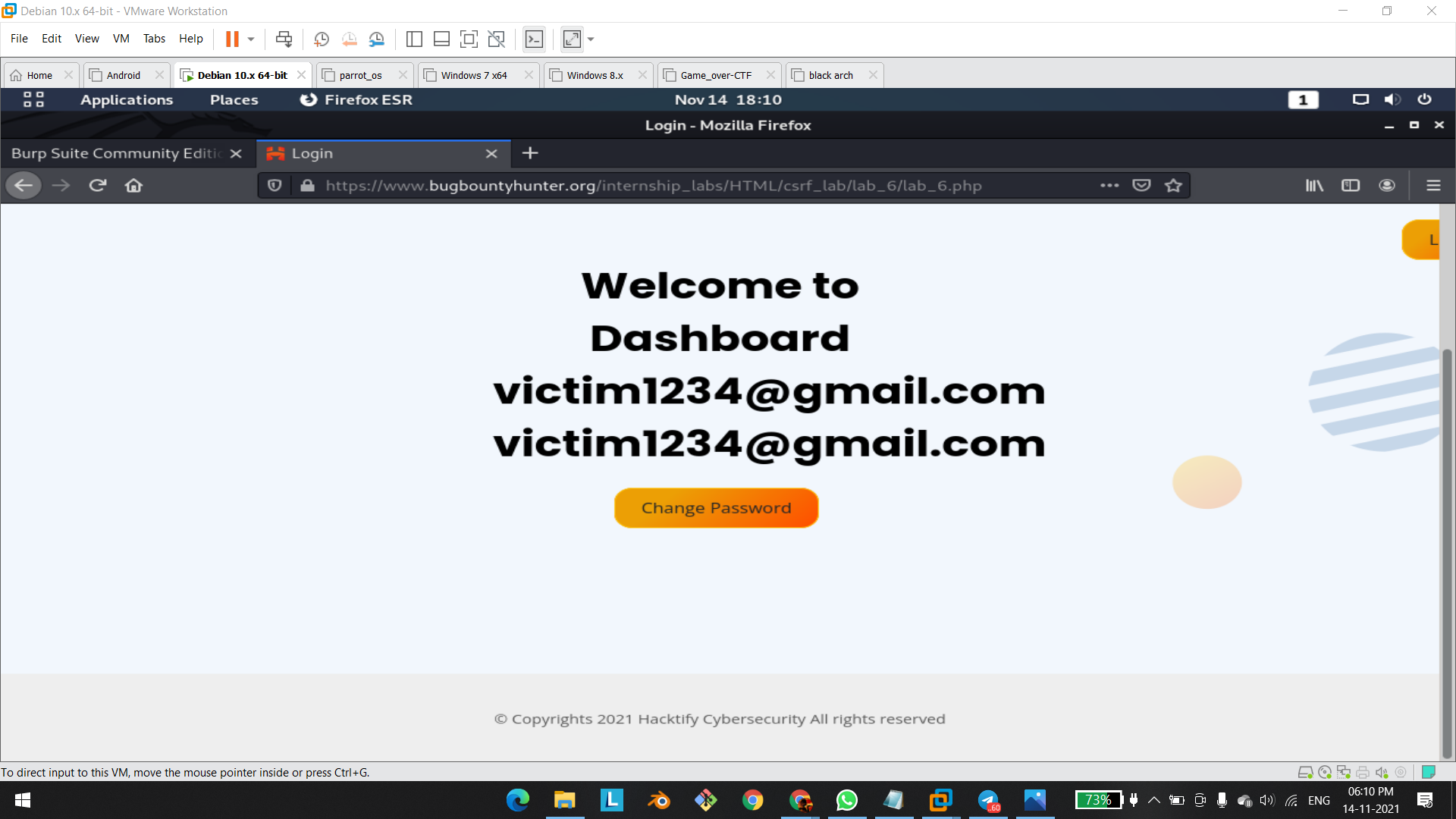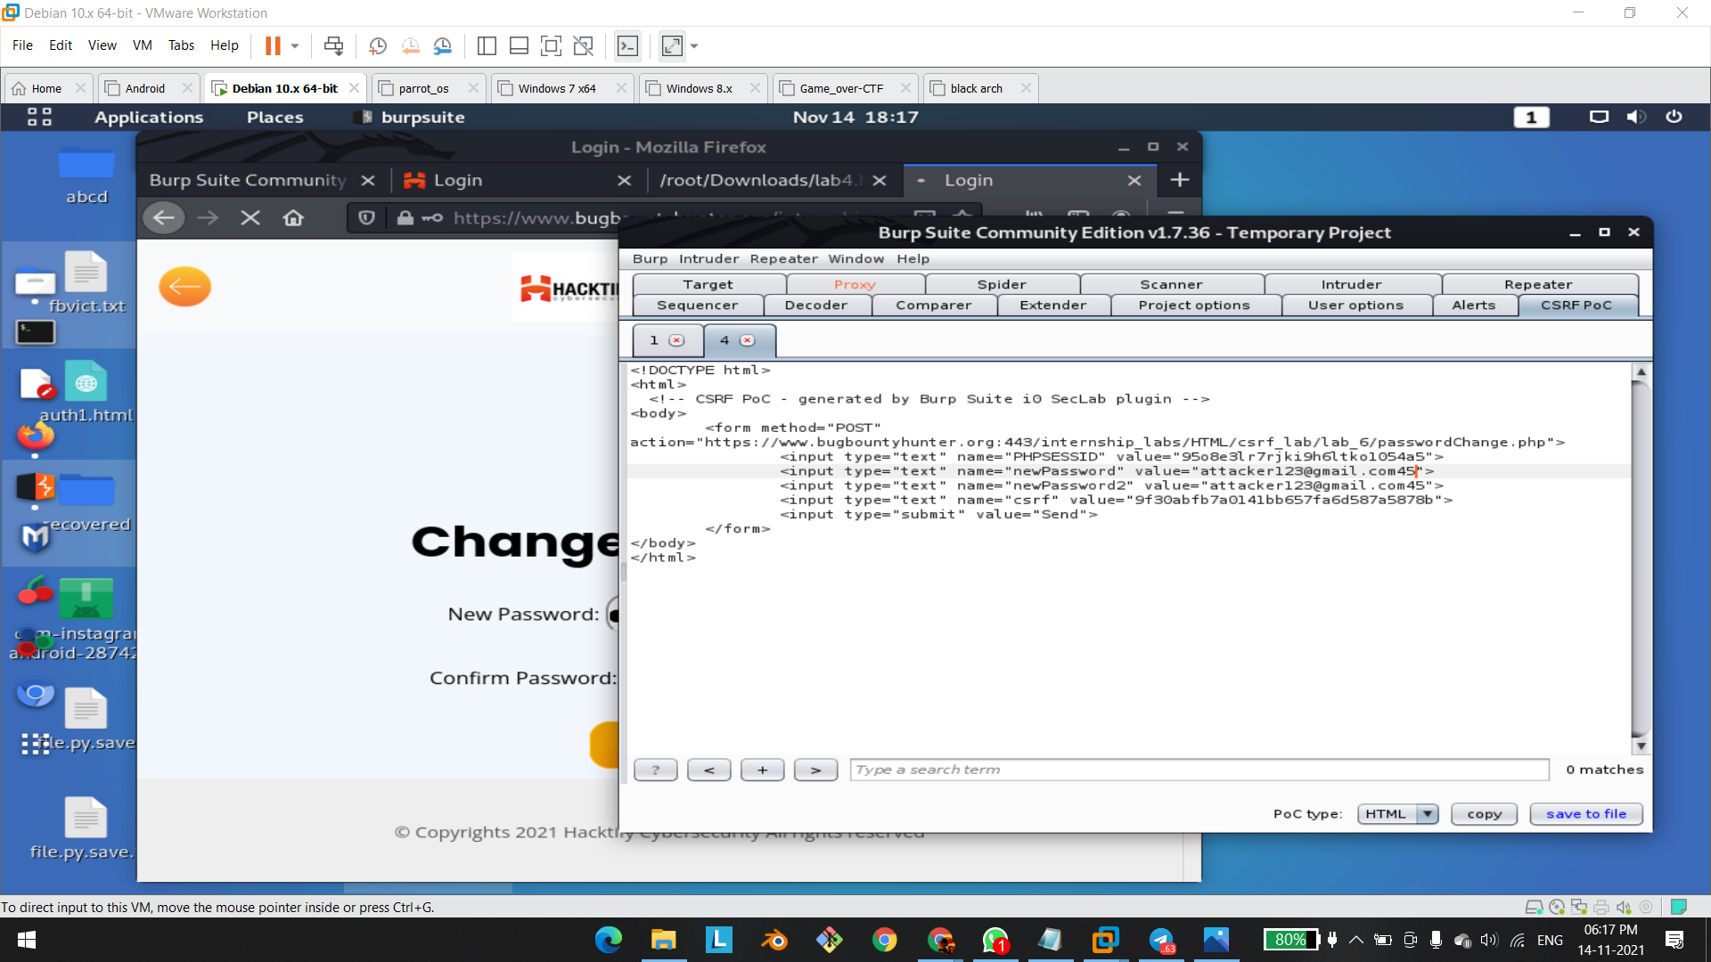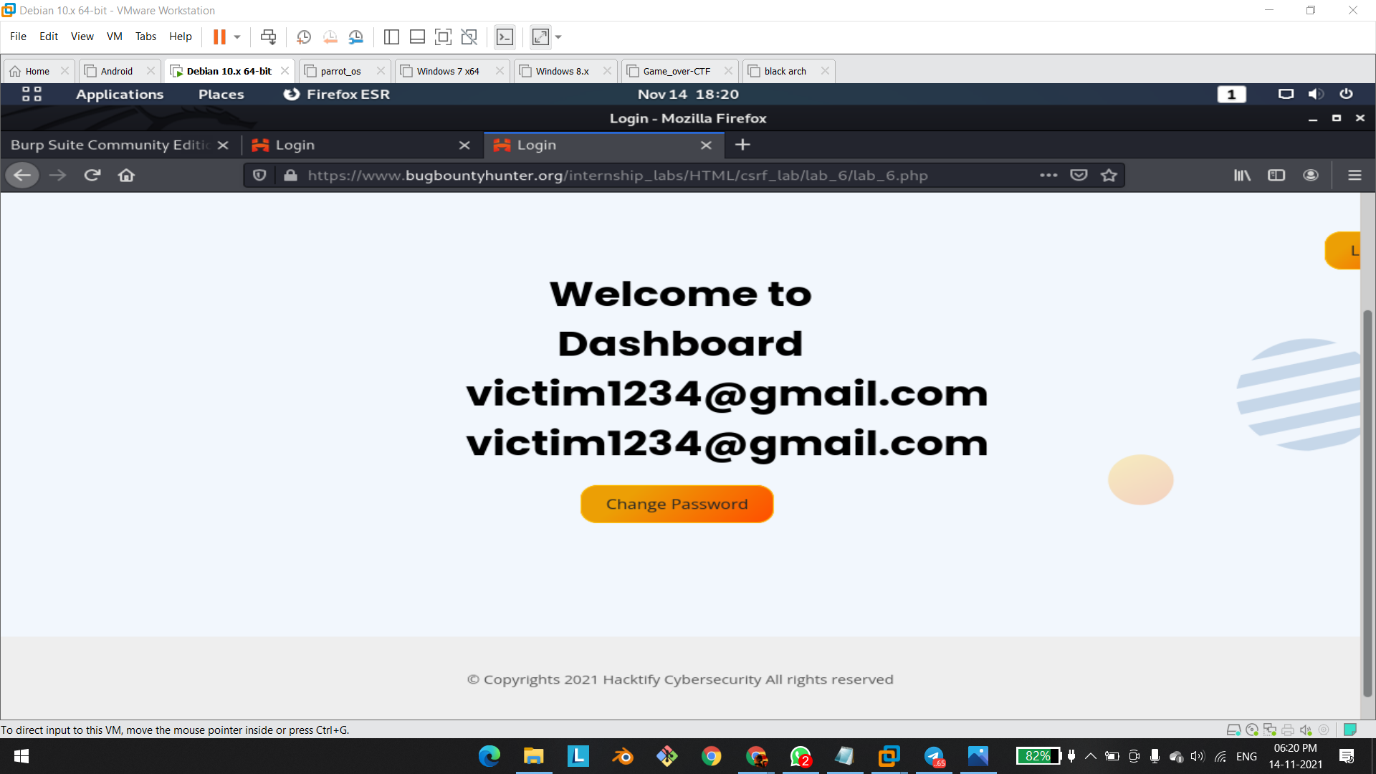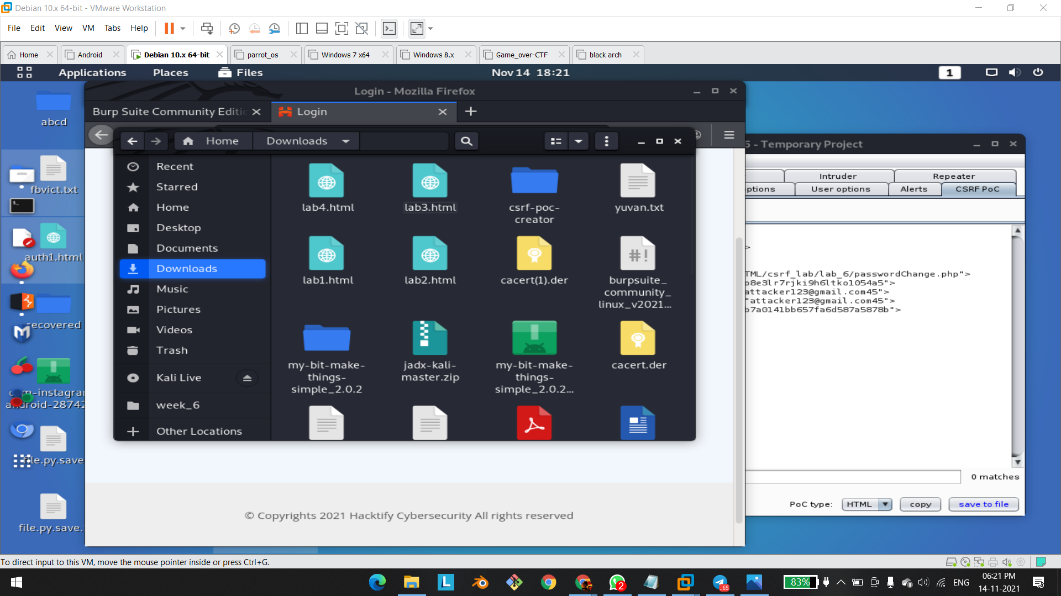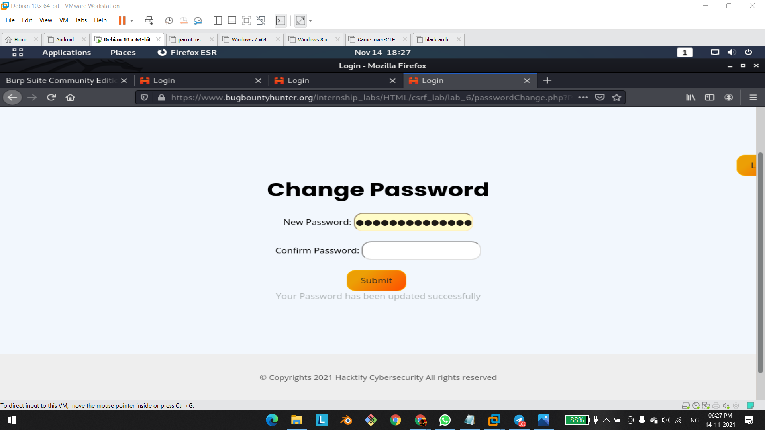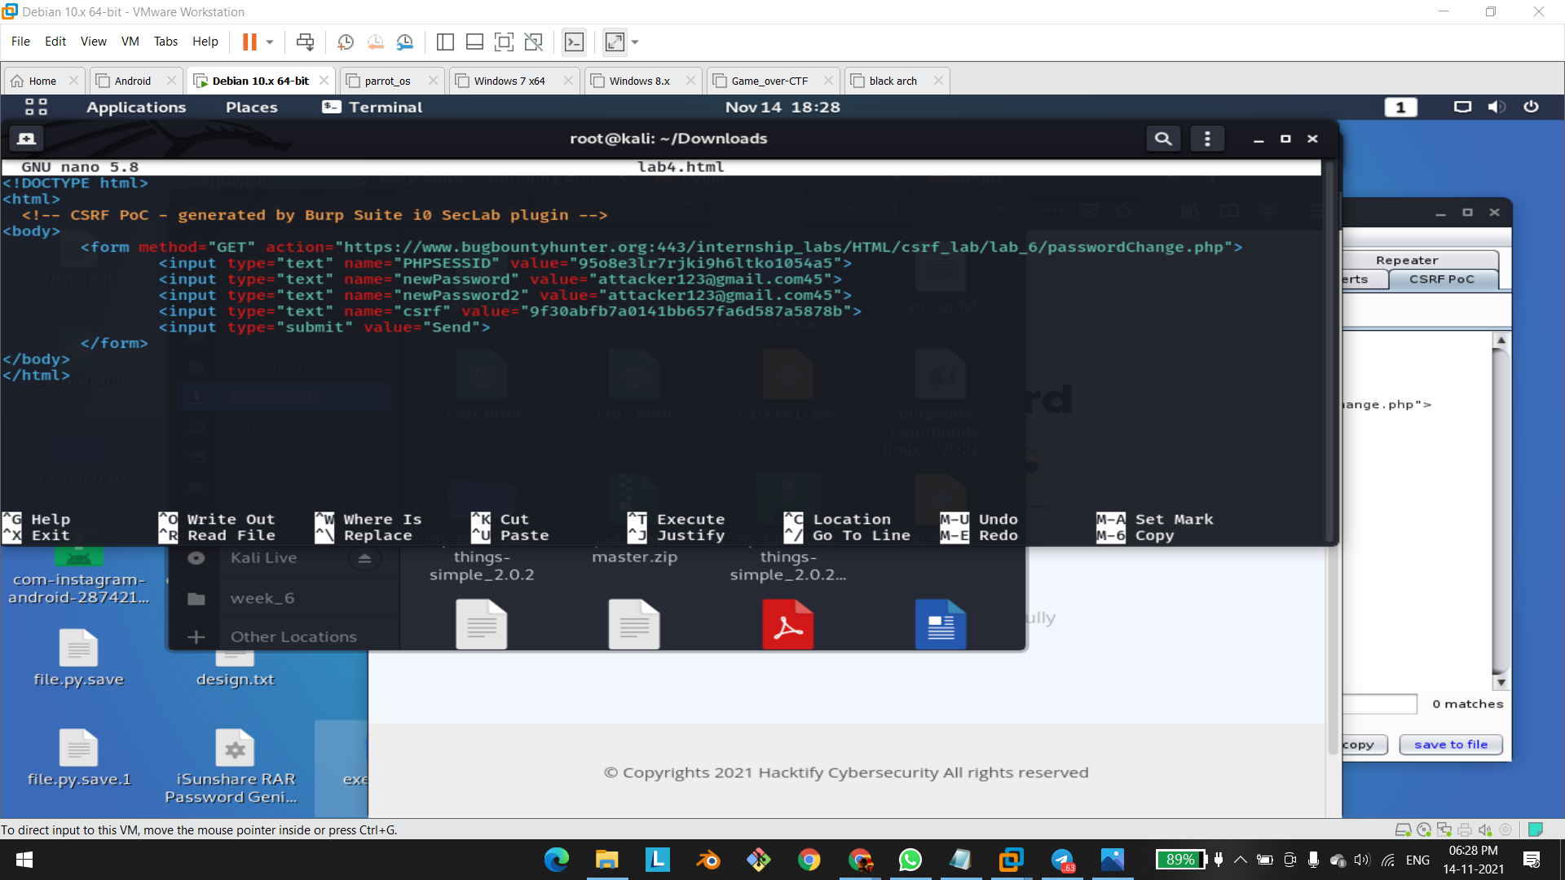

# 

# 

# 

# 

# 

# 1.5. XSS The Saviour

| **Reference** | **Risk Rating** |
| --- | --- |
| XSS The Saviour | **High** |
| **Tools Used** | |
| Burp Suite | |
| **Vulnerability Description** | |
| Cross-Site Request Forgery (CSRF) is an attack that forces an end user to execute unwanted actions on a web application in which they’re currently authenticated. With a little help of social engineering an attacker may trick the users of a web application into executing actions of the attacker’s choosing. If the victim is a normal user, a successful CSRF attack can force the user to perform state changing requests like transferring funds, changing their email address, and so forth. If the victim is an administrative account, CSRF can compromise the entire web application. | |
| **How It Was Discovered** | |
| Manual Analysis | |
| **Vulnerable URLs** | |
| <https://www.bugbountyhunter.org/internship_labs/HTML/csrf_lab/lab_7/login.php> | |
| **Consequences of not Fixing the Issue** | |
| In a successful CSRF attack, the attacker causes the victim user to carry out an action  unintentionally. Depending on the nature of the action, the attacker might be able to gain full  control over the user's account. If the compromised user has a privileged role within the  application, then the attacker might be able to take full control of all the application's data and  functionality. | |
| **Suggested Countermeasures** | |
| Same Site Cookies: CSRF attacks are only possible since Cookies are always sent with any  requests that are sent to a particular origin, which is related to that Cookie. Due to the nature  of a CSRF attack, a flag can be set against a Cookie, tuning it into a same-site Cookie. A  Cross Site Request Forgery (CSRF) 7  same-site Cookie is a Cookie which can only be sent, if the request is being made from the  same origin that is related to the Cookie being sent. | |
| **References** | |
| <https://www.acunetix.com/websitesecurity/csrf-attacks/>  <https://owasp.org/www-community/attacks/csrf>  <https://portswigger.net/web-security/csrf> | |

# 

# Proof of Concept

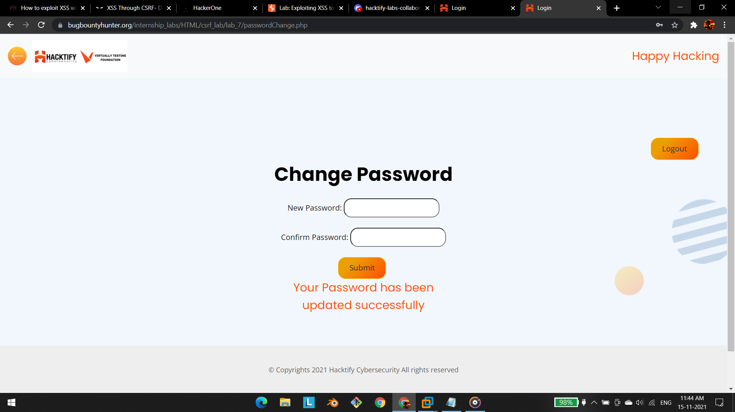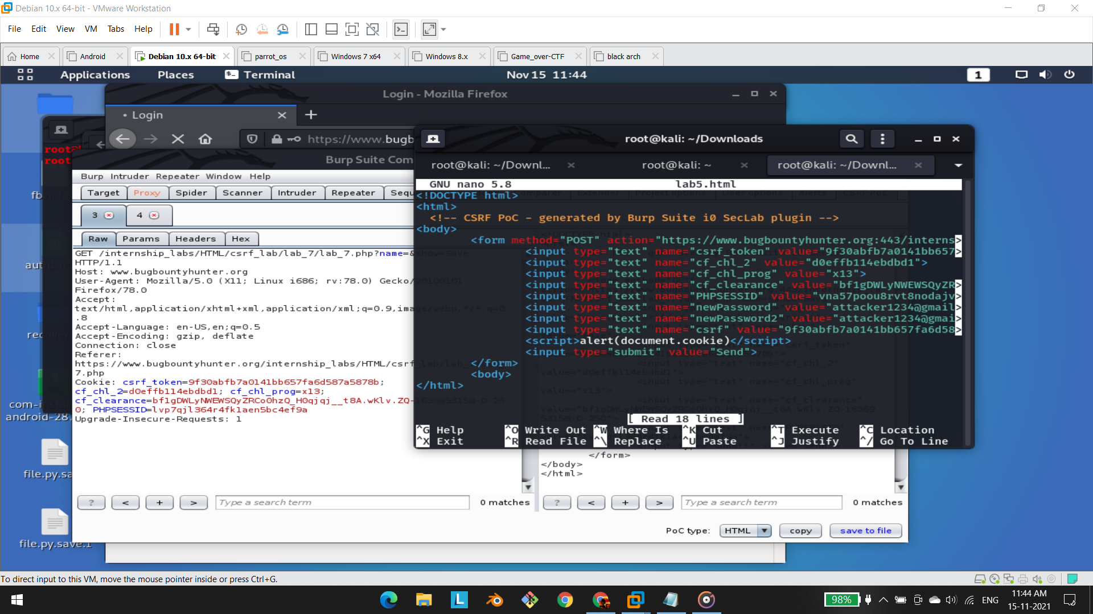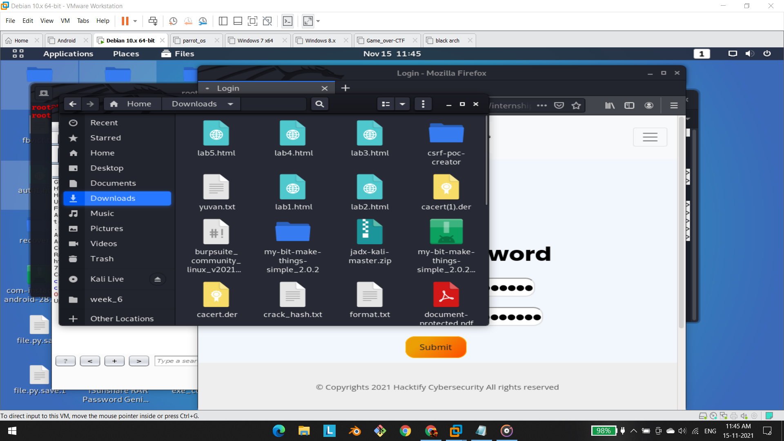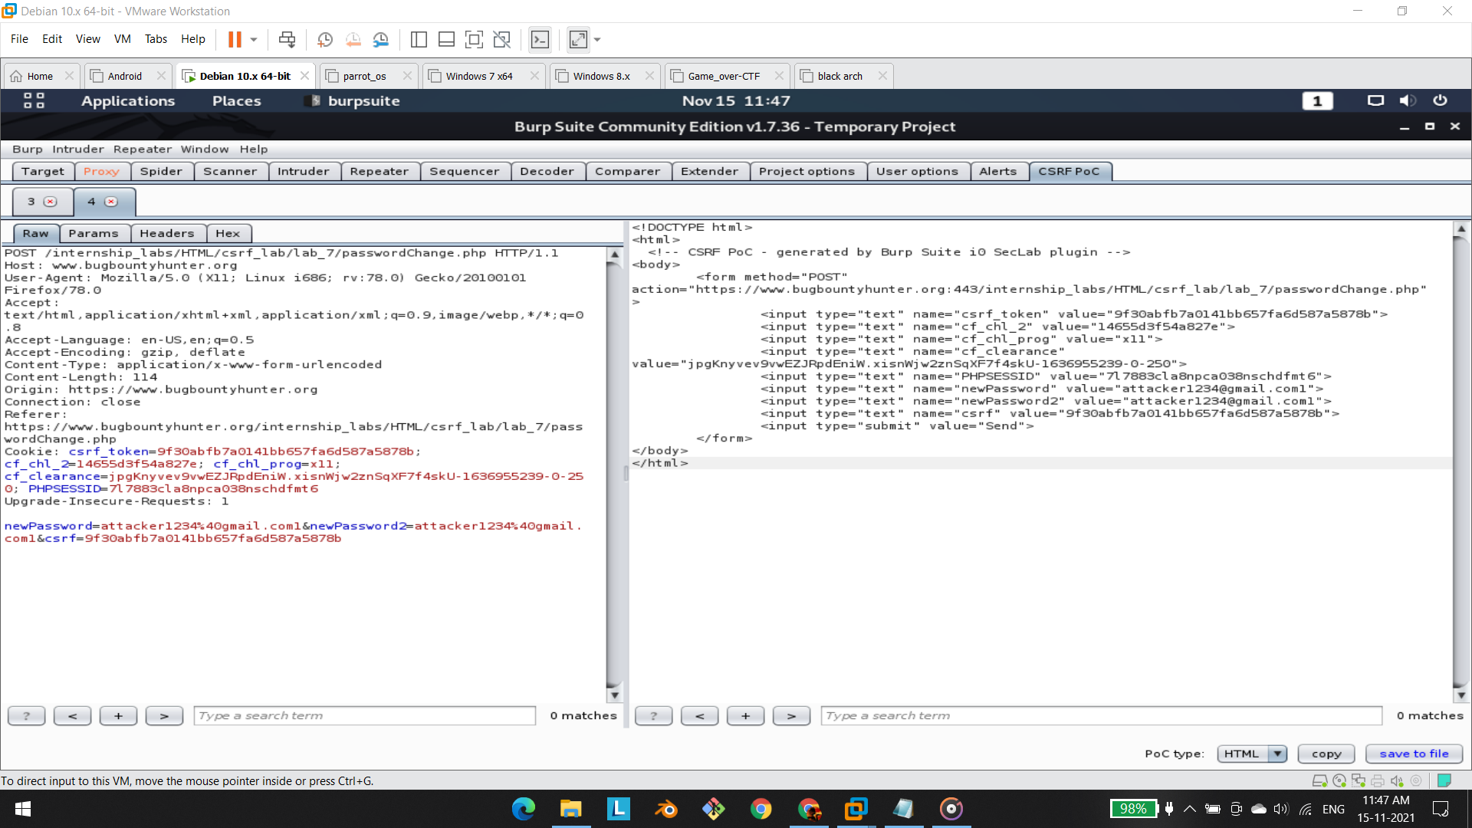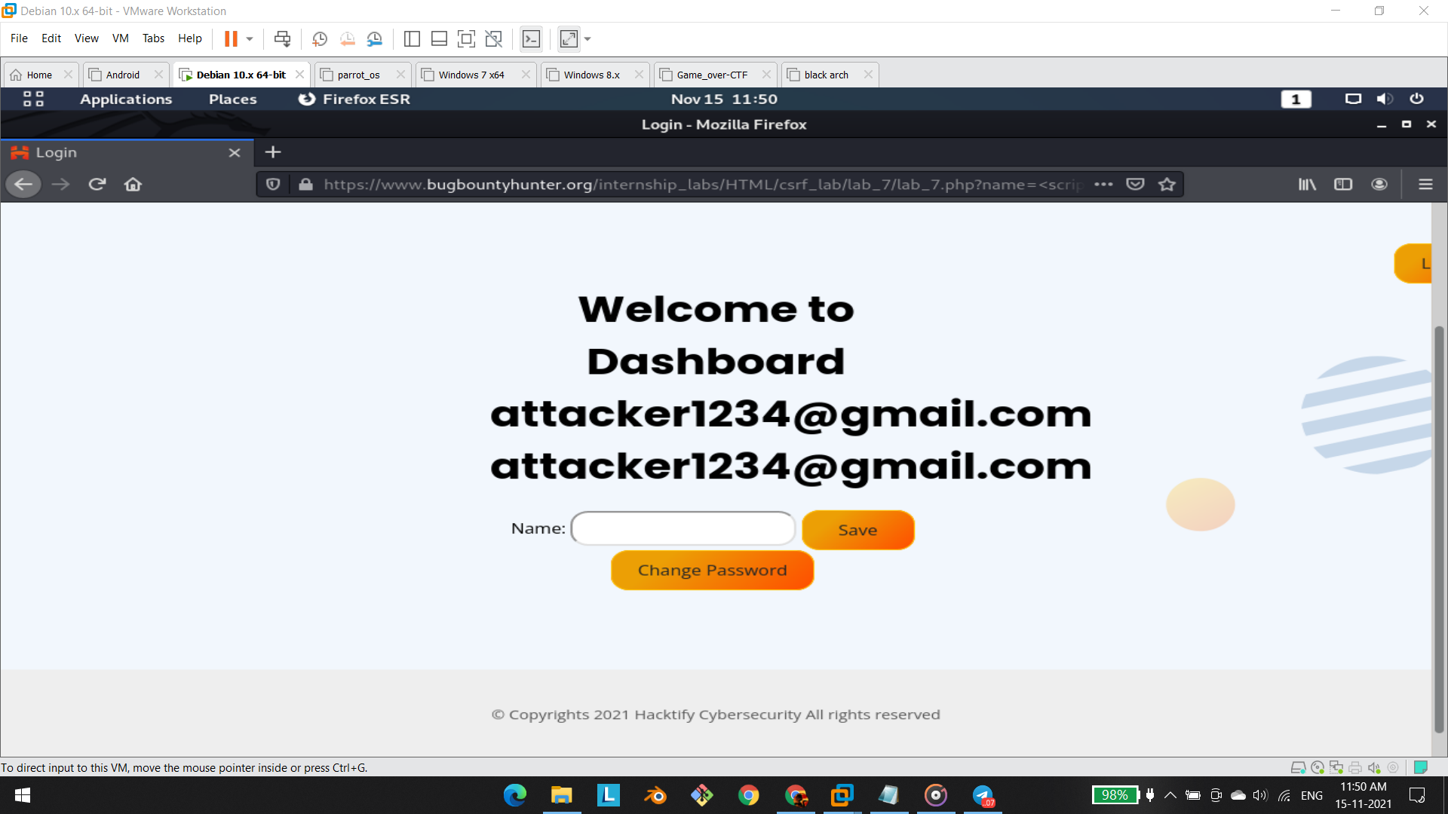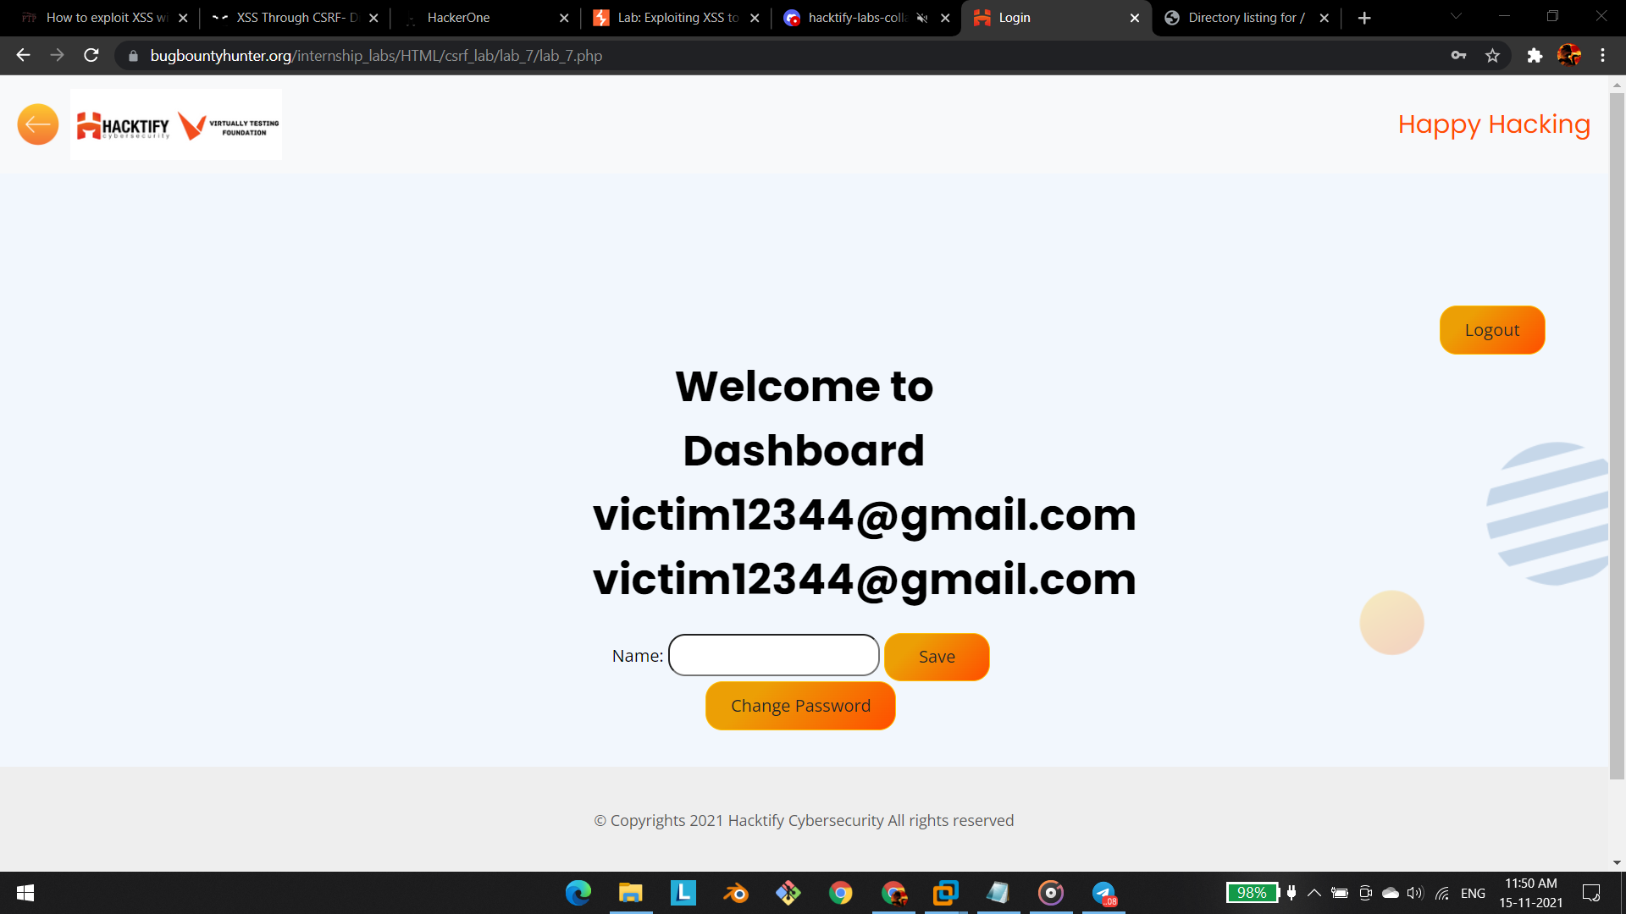

# 

# 

# 

# 

# 

# 1.6. Rm -Rf Token

| **Reference** | **Risk Rating** |
| --- | --- |
| {Sub-lab-2 Name} | **High** |
| **Tools Used** | |
| Burp Suite | |
| **Vulnerability Description** | |
| Cross-Site Request Forgery (CSRF) is an attack that forces an end user to execute unwanted actions on a web application in which they’re currently authenticated. With a little help of social engineering an attacker may trick the users of a web application into executing actions of the attacker’s choosing. If the victim is a normal user, a successful CSRF attack can force the user to perform state changing requests like transferring funds, changing their email address, and so forth. If the victim is an administrative account, CSRF can compromise the entire web application. | |
| **How It Was Discovered** | |
| Manual Analysis | |
| **Vulnerable URLs** | |
| <https://www.bugbountyhunter.org/internship_labs/HTML/csrf_lab/lab_8/login.php> | |
| **Consequences of not Fixing the Issue** | |
| In a successful CSRF attack, the attacker causes the victim user to carry out an action  unintentionally. Depending on the nature of the action, the attacker might be able to gain full  control over the user's account. If the compromised user has a privileged role within the  application, then the attacker might be able to take full control of all the application's data and  functionality. | |
| **Suggested Countermeasures** | |
| Same Site Cookies: CSRF attacks are only possible since Cookies are always sent with any  requests that are sent to a particular origin, which is related to that Cookie. Due to the nature  of a CSRF attack, a flag can be set against a Cookie, tuning it into a same-site Cookie. A  Cross Site Request Forgery (CSRF) 7  same-site Cookie is a Cookie which can only be sent, if the request is being made from the  same origin that is related to the Cookie being sent. | |
| **References** | |
| <https://portswigger.net/web-security/csrf>  <https://www.acunetix.com/websitesecurity/csrf-attacks/> | |

# 

# Proof of Concept

This section contains the proof of the above vulnerabilities as the screenshot of the vulnerability of the lab